# Contents

Contents 2

Introduction 4

Target Audience 4

Overview 4

Core Components 8

Roles of the Components Involved 8

Transition 10

Overview of this Transition Deployment Guide 10

Pre-Transitions Steps and Considerations 11

1. Understand security requirements. 11

2. Conduct a licensing assessment. 11

3. Review existing contact center configuration. 13

4. Perform network readiness assessment. 14

5. Determine call recording requirements. 15

6. Understand PSTN options 15

Cisco Provided Bundled PSTN (Option 1) 17

Service Provider (Option 2) 17

Bring Your Own PSTN (BYO PSTN) (Option 3) 18

Bring Your Own PSTN (BYO PSTN) with Local Gateway (Option 4) 20

Cloud Connected PSTN with Webex Calling (Option 5) 21

7. Understanding differences between UCCX and Webex Contact Center 22

Terminologies 22

Administration 24

User Experience 25

Reporting Considerations 27

3rd party integrations 30

Transition Steps and Considerations 30

1. Order Webex Contact Center 30

2. Implement required network and firewall changes 31

3. Prepare Webex Control Hub for directory integration and user provisioning 31

Add and verify organization domain(s) 31

Claim Organization domain(s) 32

Setup SSO 32

Suppress automated user email invitation 33

4. Enable Directory Connector integration 33

5. Provision users for Webex Contact Center 34

6. Configure dialed number (DN) for Webex Contact Center call routing 35

7. Configure agent settings (Teams, Agent Profile, Skill Profile and Multimedia Profile) 36

8. Configure call routing 39

UCCX performing call distribution 39

Overview 39

Configurations needed on your on-premises servers 41

Configurations needed on Webex Contact Center 45

CUBE performing call distribution 51

Overview 51

Configurations needed on your on-premises servers 53

Configurations needed on Webex Contact Center 55

9. Transition agents to Webex Contact Center 58

10. Transition fully to Webex Contact Center 59

Post Transition Steps and Considerations 61

1. Replace BYO PSTN with Cisco Bundled PSTN service. 61

2. Replace your Unified CM with Webex Calling. 62

3. Consider omni-channel capabilities for Webex Contact Center. 63

4. Enable ASR / TTS integrations. 64

5. Enable 3rd party integrations with custom connectors. 65

6. Integrate with CRMs using CRM connectors. 65

7. Leverage contact center artificial intelligence (CCAI). 66

8. Utilize Webex Experience Management. 67

9. Take advantage of Workforce Optimization for workforce and quality management. 67

10. Enable outbound campaigns option. 69

References 70

<Product / Solution #1> 70

<Product / Solution #2> 70

<Product / Solution #3> 70

Collaboration Transitions 70

# Introduction

This document will assist in understanding the transition path from Cisco Unified Contact Center Express (UCCX) to the Cisco Webex Contact Center platform. This will be a general overview, providing subject matter to consider as you evaluate a migration from a purely on-premises UCCX contact center deployment, to a hybrid UCCX and Cisco Webex Contact Center environment, and then perhaps ultimately to a purely Cisco Webex Contact Center environment.

General discussions are included within this document, and for the deeper configuration documentation needed for either the UCCX or Webex Contact Center systems, there are links to other documentation or mentions of inline Help screens where necessary throughout this document to assist with information capturing and or feature implementation.

## Target Audience

This transition deployment guide is intended to be used by teams or individuals with experience configuring and administering Unified Contact Center Express (UCCX) and Webex Contact Center.

This guide assumes that the reader has a basic understanding of the benefits of cloud solutions when making this transition, and what the differences are when moving from on-premises contact center to the cloud. Before proceeding, ensure you have reviewed and are familiar with the information available in the contact center transition map *Transitioning from Unified Contact Center Express to Webex Contact Center* available at <https://www.cisco.com/go/ct>.

## Overview

With the growth in cloud-based collaboration services, more and more customers are looking to move their existing contact center workloads to the cloud, given the promises of reduced total cost of ownership, simplified management, increased scalability and continuous feature delivery. As customers make the transition from on-premises contact center to cloud solution, it is important to understand what the transition entails and the steps required to make the transition.

Webex Contact Center is a unified, omni-channel cloud solution for your contact center. Built from its foundation as a cloud solution, Webex Contact Center brings your business innovation, flexibility, and the agility of the cloud, with security and scalability at its core. With its cloud-based subscription model, Webex Contact Center enables rapid time to market and rapid time to new revenue, while minimizing upfront capital investment. It also allows you to centrally manage and administer the environment, while improving customer experiences and optimizing business results.

The purpose of this document is to provide transition guidance for customers specifically looking to move from an on-premises UCCX deployment to Webex Contact Center in the cloud.

As shown in Figure 1, a typical deployment of a UCCX and collaboration environment includes many different collaboration infrastructure components on the network: a call control platform, an edge platform, hardware and software agent calling endpoints, the contact center platform, and in some cases even conferencing and scheduling platforms.

In the Cisco architecture, this would include Unified Communications Manager (Unified CM) for call control, UCCX for contact center routing, Cisco Unified Border Element (CUBE) for edge services, Cisco Meeting Server / Meeting Management (CMS/CMM) for on-premises conferencing, Unity Connection for voice messaging, and end-user facing IP endpoints such as desk phones (for example, IP Phones and Webex DX) and software endpoints (Jabber). These components may vary slightly in some environments, but this is the starting point for the transition described in the rest of this document.

Figure 1. *Before: On-Premises Collaboration Architecture including Contact Center Express*

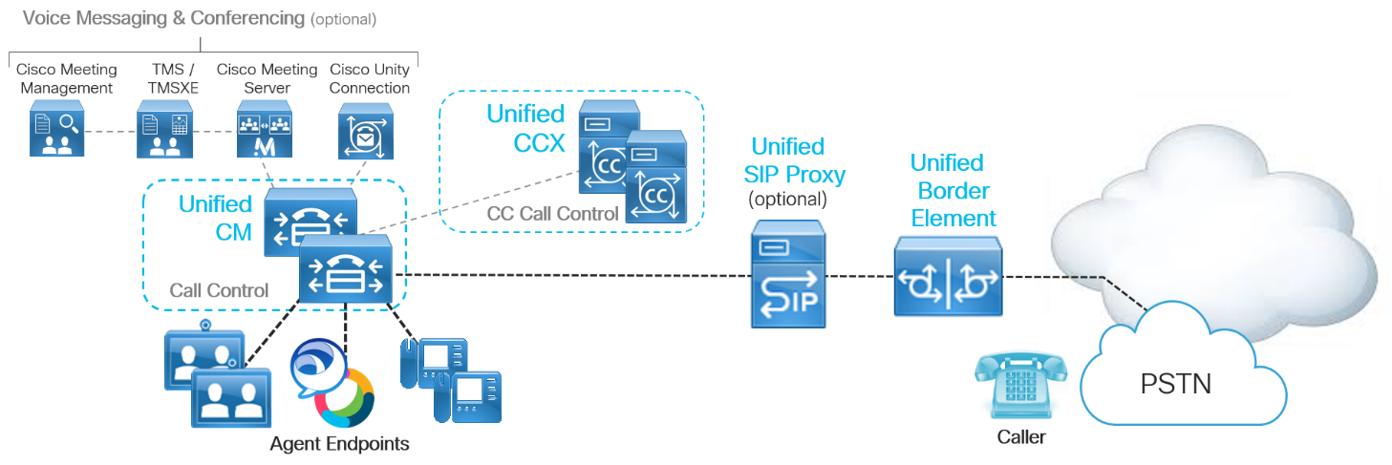

Table 1 lists the key elements of the on-premises architecture prior to transitioning to Webex Contact Center in the cloud.

Table 1. *On-Premises Collaboration Infrastructure including Cisco UCCX*

|  |  |
| --- | --- |
| Product | Description |
| Cisco Unified CM | On-premises call control providing device registration and call routing services. |
| Cisco Unified CCX | On-premises contact center platform for SMB customers providing call queuing, interactive voice response (IVR) treatment, scripting, and intelligent call routing services. |
| Cisco Unified Border Element (CUBE) | Edge infrastructure providing connectivity to the PSTN cloud for external call routing and IP session border control for IP calling traffic. |
| Cisco Unified SIP Proxy (CUSP) | Call routing engine which aggregates SIP-based network elements for easier centralized routing. [Optional] |
| Cisco Unity Connection | On-premises voice messaging platform providing voicemail and unified messaging capabilities. [Optional] |
| Cisco Meeting Server (CMS), Cisco Meeting Management (CMM), and Cisco Telepresence Management Suite (TMS) | On-premises voice, video, and web conferencing infrastructure, providing multipoint meetings, meeting management and scheduling capabilities. [Optional] |

Customers who wish to start leveraging cloud contact center solutions should consider Webex Contact Center. This cloud contact center service allows the customers to leverage the Cisco Webex global architecture for scalability and connectivity.

As illustrated in Figure 2, customers who have an on-premises Unified CM and UCCX may choose to transition this architecture to cloud Webex Contact Center, while retaining on-premises Unified CM for phone registration and call routing. The decision needs to be made based on customer’s functionality requirements.

Figure 2.  *On-Premises UCCX Transition to Cloud-based Webex Contact Center Decision*

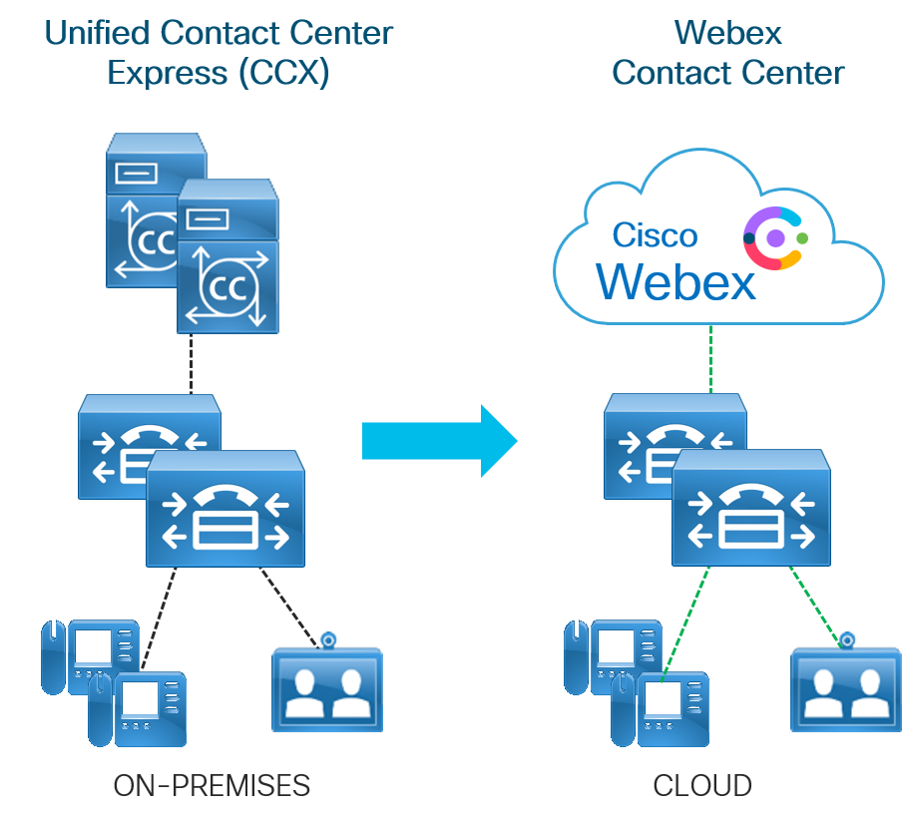

Customers that have the following conditions should consider carefully before making the decision to embark on this transition:

* Stringent data privacy policies.
* Unreliable internet access.
* Compliance requirements for on-premises or on-country media recording and storage.
* A need to continue using on-premises UCCX for historical reporting data.
* A need to continue to integrate complex or numerous on-premises custom integrations with other solutions.

# Core Components

## Roles of the Components Involved

The target architecture for this migration includes a few new components. These new components include the Webex Contact Center service, Directory Connector for identity integration, Webex Contact Center Portal for configuration and administration of Webex Contact Center and Webex Control Hub for administration of users.

As shown in Figure 3, the new components (Webex Contact Center and Directory Connector) are added to the existing on-premises deployment environment.

Figure 3. *After: Webex Contact Center Architecture*

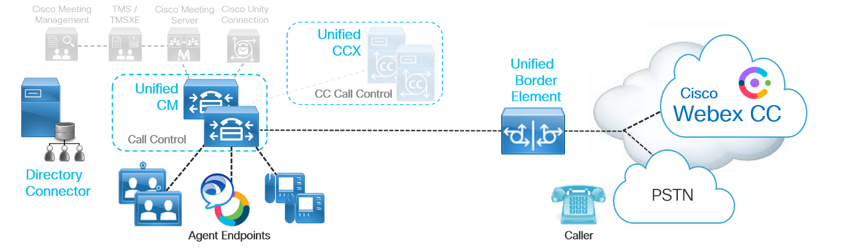  
Table 2 lists the new elements of the architecture after transitioning to Webex Contact Center

Table 2. *After: Webex Contact Center Infrastructure Components*

|  |  |
| --- | --- |
| Product | Description |
| Cisco Webex Contact Center | Cloud-based contact center service delivered from Cisco Webex platform providing queuing, IVR treatment and intelligent call routing capabilities. |
| Cisco Directory Connector | Windows application running on a Windows domain machine providing identity synchronization between enterprise Active Directory and the identity store of the Webex organization. |
| Cisco Webex Contact Center Portal | Cloud-based configuration and administration tool for Webex Contact Center. |
| Cisco Webex Control Hub | Cloud-based configuration and administration tool integrated with Webex Contact Center and other elements of the Cisco collaboration portfolio. |
| Voice Point of Presence (vPOP) | This is a legacy element of the Webex Contact Center environment that is a routing point for all IP voice traffic. This element will not be required in some of the architecture options discussed within this document. |

# Transition

## Overview of this Transition Deployment Guide

This document describes a phased transition in two parts. As shown in Figure 4, the initial transition phase (Phase 1), results in a hybrid deployment where some queues and agents are transitioned to Webex Contact Center, and the rest remain on the existing UCCX. The final transition phase (Phase 2), results in a purely cloud hosted contact center environment, where all the contact center queues and agents are fully transitioned to Webex Contact Center.

It is important to understand that during the hybrid phase (phase 1) as well as after the final transition (phase 2) to pure cloud contact center, the agent devices continue to register to on-premises Unified CM for call processing.

**Note:** This document does not cover transitioning call control from on-premises Unified CM to cloud Webex Calling.

How long an organization takes to transition to Webex Contact Center fully will vary on multiple factors. Some of them include time needed to train the contact center agents/supervisors, feature parity between UCCX and Webex Contact Center, and configuring all necessary call routing scripts. This document covers both the hybrid (Phase 1) and full transition (Phase 2) phases of a migration.

Figure 4. *Phased Contact Center Transition: Hybrid and Cloud*

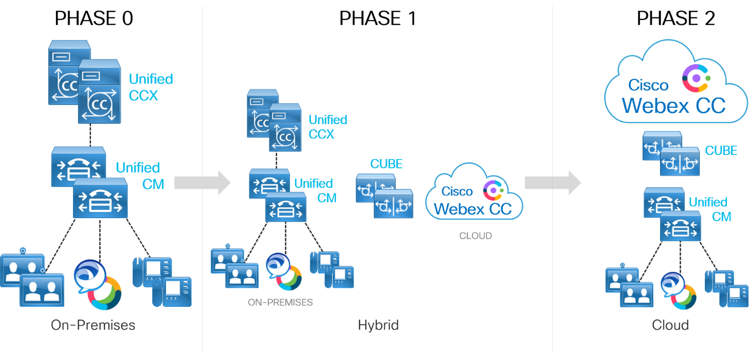

This section covers the pre-transition preparation steps, the transition implementation steps, and the post-transition steps to be considered for this workflow transition.

## Pre-Transitions Steps and Considerations

Below is a summary of pre-transition items/steps to consider when performing the transition from UCCX to Webex Contact Center.

Prior to embarking on a transition, in order to determine the feasibility and potential modifications required, it is important to consider aspects of your existing environment. Likewise, you must understand the key elements of the Webex Contact Center offer in comparison with the existing on-premises deployment.

1. Understand security requirements.

Understanding the security requirements when transitioning to cloud is one of the vital steps in the transition process. Engage your security and risk assessment team as a first step when you are considering transitioning to cloud. Understand all the regulatory compliance and certifications in place for Webex Contact Center to protect your data and ensure that they comply to your organization requirements.

The other key aspect to understand when it comes to security in the system is understanding what contact center data is stored in the Webex cloud. Webex Contact Center stores the following five data types:

* Call Detail Records
* Connected Agent Records
* Agent Desktop Data
* Call Variables stored by IVR
* Call Recordings

For more specific details on how Webex Contact Center handles personal data, certifications and compliance, consult the *Webex Contact Center Privacy Data Sheet* available at <https://trustportal.cisco.com/c/dam/r/ctp/docs/privacydatasheet/collaboration/cisco-customer-journey-privacy-data-sheet.pdf>.

1. Conduct a licensing assessment.

Webex Contact Center is licensed using Flex licensing. Understanding the current licensing structure of an existing on-premises deployment is a key consideration in this migration. Cisco Collaboration Flex Plan Contact Center is a single subscription model that gives you access to Cisco contact center products with the flexibility to migrate from one deployment model to another at your own pace, when you are ready.

You will need to perform a license assessment of the following areas of your existing on-premises UCCX solution.

* Platform

The ability to fully articulate what is currently licensed on your core platform will be critical when working with your accounts team or partner to determine the best path to Flex licensing. Table 3 summarizes some of the information needed when evaluating your Flex licensing needs.

**Table 3**.*Platform Licensing Information to Capture*

|  |  |
| --- | --- |
| Information | Comment |
| Enhanced or Premium package | UCCX provides enhanced or premium licensing. Capturing this information is important and will help you understand if you need basic contact center features or advanced features when migrating to Webex Contact Center. |
| Agent seat licenses | Webex Contact Center offers Flex licensing. Licenses are purchased based on agent counts, therefore knowing the number of agent seat licenses is vital when having conversations with your account team and/or the partner. |
| Outbound dialer | Evaluating if you need any additional features such as an outbound dialer is critical. |
| IVR port licenses | Evaluate the number of interactive voice response (IVR) port licenses required to be sure to obtain the proper number in your Webex Contact Center environment to meet your IVR needs. |
| Workforce Optimization (WFO) | Workforce Optimization is also a cloud offering. If you need WFO service, you need to start evaluating transitioning this to cloud Webex Workforce Optimization along with Webex Contact Center. |

For more information refer to Cisco Collaboration Flex Plan Contact Center available at: <https://www.cisco.com/c/en/us/products/collateral/unified-communications/cisco-collaboration-flex-plan/datasheet-c78-741220.html>.

* Cisco Unified Border Element (CUBE)

Because CUBE is required for PSTN access for this transition, CUBE licensing must also be considered. For more details on CUBE licensing, refer to <https://www.cisco.com/c/en/us/products/collateral/unified-communications/unified-border-element/data-sheet-c78-729692.html#Licensing>

1. Review existing contact center configuration.

Understanding how your UCCX deployment is configured is very critical when determining the best path to migrate to Webex Contact Center.

Table 4 summarizes some of the key considerations when reviewing your UCCX configuration.

Table 4. *Existing UCCX Configuration Information to Capture*

|  |  |
| --- | --- |
| Information | Comment |
| Queues configured | Evaluate the number of teams and queues configured in your UCCX system. This helps you when evaluating your phased transition approach. |
| Concurrent agents and supervisors | This helps you understand the network bandwidth requirements and situations that may create overage charges, if any. |
| Non-voice channel configurations | Do I need chat and email functionality? If you don’t currently support contact center chat and email in your existing UCCX deployment, you may not require premium agent licenses in Webex Contact Center. This needs to be evaluated before the transition. |
| 3rd party integrations | Are there any 3rd party integrations with on-premises Contact Center Express? If yes, where are they hosted? 3rd party integration traffic needs to be considered when calculating network requirements. If they are hosted in a cloud, then cloud-to-cloud connectivity needs to be tested. |
| ASR/TTS requirement | This is an add-on license in Webex Contact Center. Knowing whether ASR/TTS (Automatic Speech Recognition / Text to Speech) service is needed, helps you evaluate the Flex license that needs to be purchased. |
| Agent call recording | Call Recording is an important consideration for a contact center. Since most contact centers have various compliance requirements with respect to call recording and storage, understanding your existing UCCX setup is vital. |

1. Perform network readiness assessment.

You will need to consider your existing service provider data connections (MPLS, SD-WAN, and so on) and generally plan for direct internet access at each location within your deployment. Because you will be consuming cloud-based services, reliable Internet connectivity with sufficient bandwidth is a base requirement.

You should reconsider making this transition to a cloud-based contact center if your organization locations’ internet connection(s) are not generally reliable, have less than adequate upstream and downstream throughput, or have high latency issues currently. Some application integrations run on their own vendor cloud, so verifying cloud-to-cloud connectivity is also important.

All call legs are anchored on the Webex Contact Center vPOP CUBE/Access SBCs. For this reason, it is vital that all the call legs and number of concurrent calls for your deployment are considered for bandwidth calculations. VoIP industry standards dictates latency be <150ms end-to-end, jitter <30ms, and packet loss <1%. While not a formal bandwidth calculator, you can use the *Webex Network Test* tool available at <https://mediatest.ciscospark.com/#/main/> to evaluate the speed and performance of your network location.

You can also use the following general formula when calculating the required audio call bandwidth:

*(Number of expected concurrent calls) * (Bandwidth per call based on codec) = (Required network throughput)*

For example, if you decide to keep your call control on-premises (Unified CM), the only supported codec between an on-premises CUBE and the Webex Contact Center vPOP is the G.711 codec, requiring 80 kbps. So, the formula would be:

*(Number of expected concurrent calls) \** **80 kbps** *= (Required network throughput)*

**Note:** The bandwidth calculation example considered above does not account for video calls.

When calculating desktop bandwidth consumption, you will also need to consider Management Portal traffic, Analyzer traffic, Agent Desktop, video chat and 3rd party cloud applications and integrations.

1. Determine call recording requirements.

Call Recording is offered by Jukebox (a Cisco call recording solution). All the recorded media is securely kept in the cloud. By default, the recordings are stored in the cloud for 3 years. If your business or industry compliance and regulations require that stored/recorded media be kept on-premises or in your country of deployment, you should work with your Cisco account team and/or partner to understand other available options.

1. Understand PSTN options

When it comes to PSTN access for Webex Contact Center, it is important to understand the following considerations:

* PSTN is required for off-net calling
* Cisco itself never supplies the PSTN, as that would be provided by 3rd party carriers

There are multiple options when choosing PSTN service. Consider all the available PSTN options before selecting the option that best suits your organization.

**Note:** Understanding all available PSTN options before making a choice is a very important step. You cannot change the PSTN option once it is configured for a tenant.

As shown in Figure 5, there are five different options for PSTN service.

Figure 5. *All 5 PSTN Options*

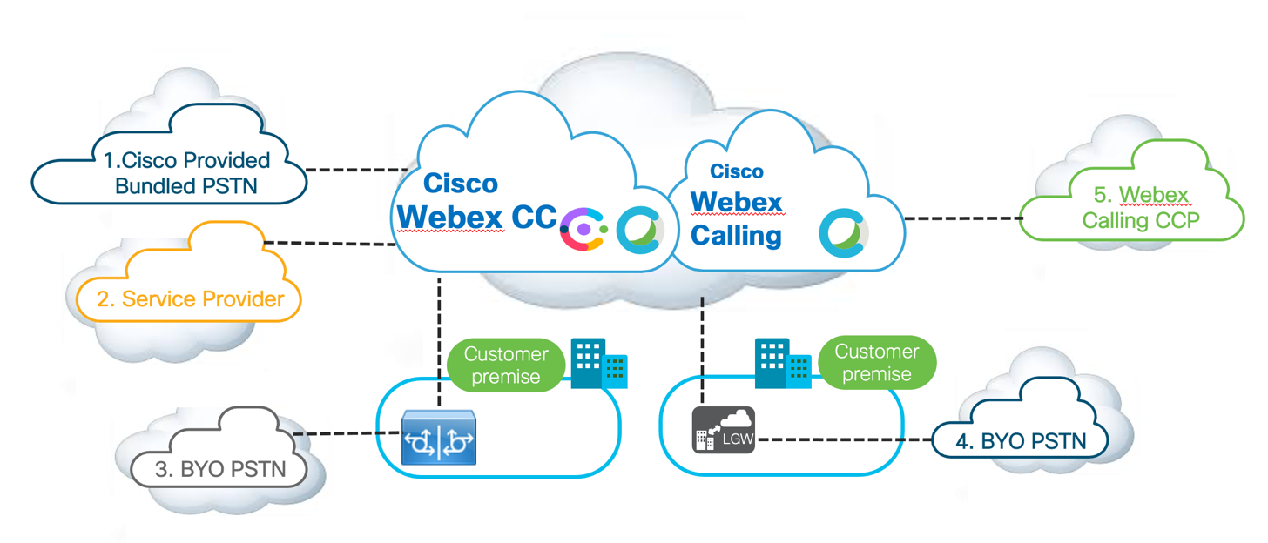

Though most of the steps/requirements for this transition remains the same irrespective of the PSTN option chosen, some of the requirements may vary (such as network bandwidth requirement, CUBE licenses, and so on).

If you decide to transition only the contact center service to the cloud and maintain call control on-premises (Unified CM), then only PSTN options 1 (Cisco-provided Bundled PSTN), 2 (Service Provider partners), and 3 (Bring Your Own PSTN (BYO PSTN) with CUBE) apply.

**Note:** This document only discusses details for the transition from UCCX to Webex Contact Center using Bring Your own PSTN (BYO PSTN) with CUBE and on-premises Unified CM call control (option 3).

If you decide to transition your calling to cloud Webex Calling platform along with the transition to Webex Contact Center, options 4 (Bring Your Own PSTN (BYO PSTN) with Local Gateway (LGW)) and 5 (Webex Calling Cloud Connected PSTN (CCP)) are the available PSTN options.

The call flow and signaling varies depending on which PSTN option you choose and each of them are discussed in the sub-sections below.

**Webex Contact Center without Webex Calling - PSTN Options (Options 1, 2 and 3)**

#### Cisco Provided Bundled PSTN (Option 1)

This add-on is a Cisco provided, flat rate PSTN calling service for Webex Contact Center. This service includes local number access into Webex Contact Center plus PSTN termination of the call to the agent. It also offers toll-free access into Webex Contact Center. Some of the advantages with Cisco PSTN are:

* It is comprised of Cisco-vetted and managed PSTN carriers.
* You receive a single invoice for both PSTN services and agent subscriptions.
* Cisco manages porting your existing numbers and/or acquiring new numbers.

**Note:** Cisco Provided Bundled PSTN is currently only available in US and Canada regions. Toll-free access into Webex Contact Center is only available in the US.

Figure 6 shows the PSTN signaling and RTP flow with Cisco provided bundled PSTN**.**

Figure 6. *Cisco Provided Bundled PSTN Signaling and RTP Flow*

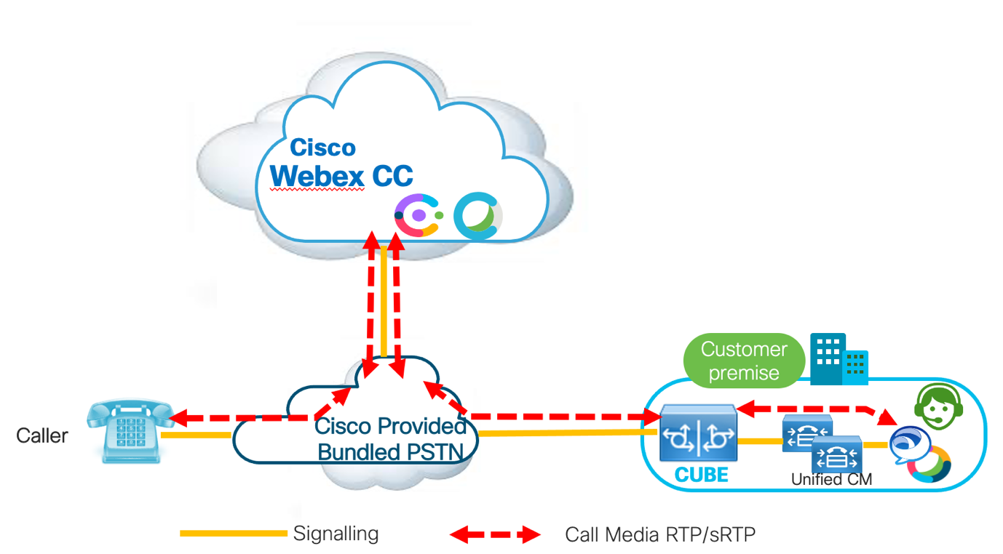

#### Service Provider (Option 2)

Cisco has partnered with multiple Service Providers who offers PSTN service into Webex Contact Center. The Service Provider’s call control, provided via a branded Broadworks call control service, will terminate calls within the Service Provider’s network. The service provider will have a CUBE within their environment that will then allow extension of their network into Webex Contact Center’s traditional vPOP deployment, which also includes a CUBE providing the connection to the Webex Contact Center’s calling services. Agent call termination is still offered through PSTN in this call flow.

**Note:** The type of Cisco phones that can be registered via Broadworks can be seen in the Broadworks Support Quick Start Guide available at <https://www.cisco.com/c/dam/en/us/td/docs/voice_ip_comm/cuipph/MPP/common/bsqsg/MPP-Quick-Start-Guide-V1_1.pdf>.

Figure 7 shows the PSTN signaling and RTP flow in this scenario.

Figure 7. *Cisco Service Provider Partners Signaling and RTP Flow*

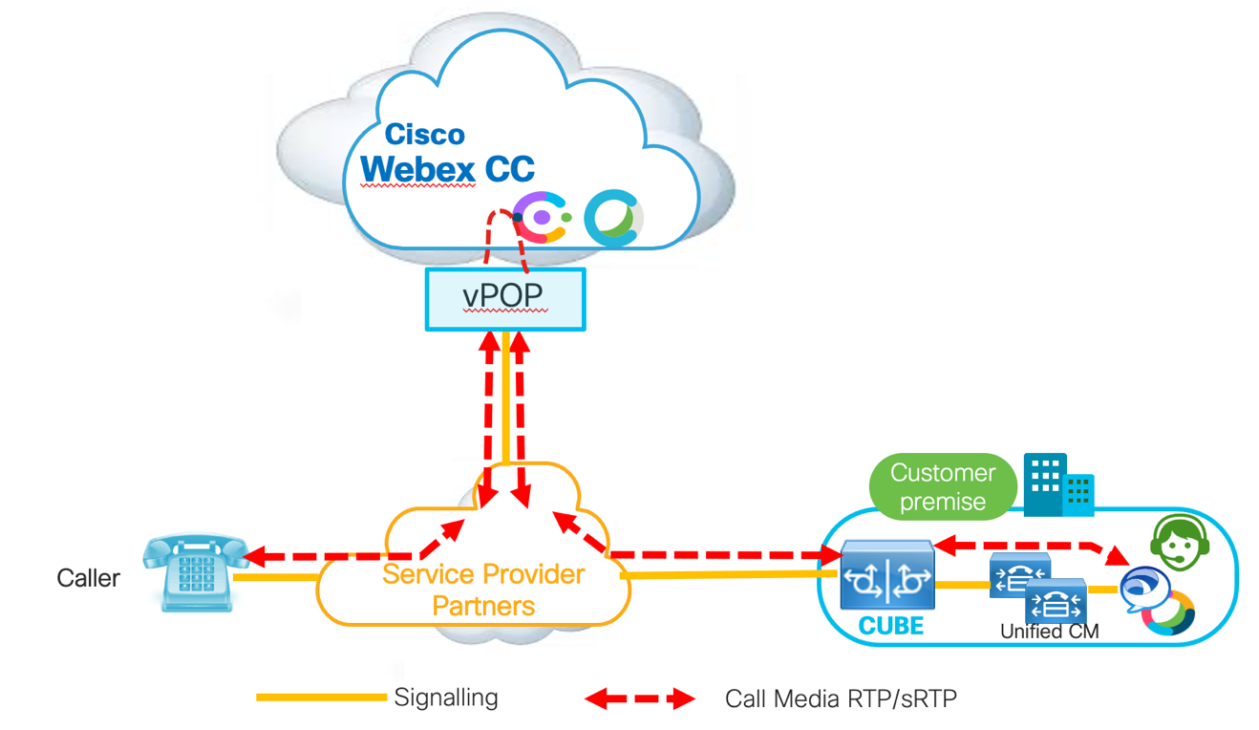

#### Bring Your Own PSTN (BYO PSTN) (Option 3)

With BYO PSTN, you can bring your existing direct access PSTN connectivity. This PSTN option terminates in your corporate network and is then extended to Webex Contact Center cloud via VoIP (voice over IP). In this setup, the on-premises CUBE acts as a gateway between the PSTN network and Webex Contact Center. Network considerations discussed earlier in this document play a key role when choosing this PSTN option, as the agent leg traverses the existing corporate data connections (SD-WAN, MPLS, and so on).

Figure 8 shows the BYO PSTN Signaling and RTP flow.

Figure 8. *BYO PSTN Signaling and RTP Flow with CUBE*

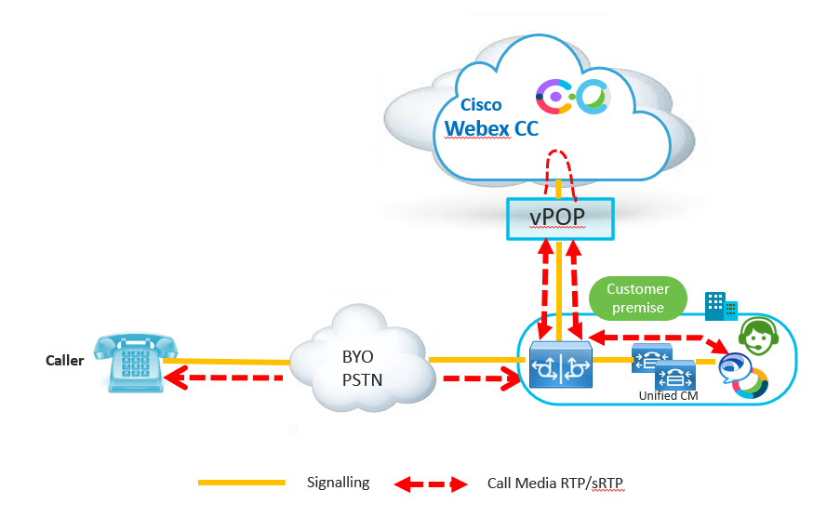

**Webex Contact Center with Webex Calling - PSTN Options (Option 4 and 5)**

Webex Contact Center with Webex Calling offers customers both Cisco’s cloud calling and cloud contact center capabilities together, entirely as Software as a Service (SaaS) offer.

As a cloud-based subscription, it helps in minimizing your upfront capital investment, enables rapid time to market, reduces administrative overhead by having single pane of glass (SPOG) administration and management and brings your business the innovation and agility provided by the cloud. Webex Calling is a complete enterprise-grade Cisco cloud calling solution offered through a flexible subscription model.

You could choose to keep both Unified CM and Webex Calling as your call processing systems in parallel or adapt a phased approach and transition your calling fully to the Webex Calling cloud offering.

Figure 9 shows the PSTN connectivity options specifically available for Webex Calling. Customers have an option of bringing their own PSTN under BYO PSTN or to opt for Cloud Connected PSTN (CCP).

Figure 9. *Webex Calling PSTN Connectivity Options*

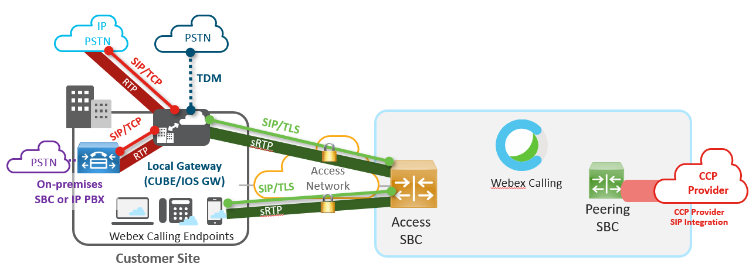

Cisco provides the option to bring your own PSTN (BYO PSTN) which is terminated on a Local Gateway (LGW). The Local Gateway is an essential component if you are switching to Webex Calling. The Local gateway platform must be either a Cisco Integrated Services Router (ISR) 4000 series, Cisco 1100 ISR series, or Cloud Services Router (CSR1000v) series.

There are multiple factors to consider when you switch from Unified CM to Webex Calling including specific network requirements and dial-plan changes which are critical to this transition.

To understand how to transition to cloud Webex Calling and to review information on a phased transition plan from Unified CM to Webex Calling, please refer to the deployment guide named *Transitioning from Unified CM to Webex Calling Deployment Guide* available at: <https://www.cisco.com/c/dam/en/us/td/docs/solutions/PA/mcp/DEPLOYMENT_CALLING_Unified_CM_to_Webex_Calling.pdf>.

The sub-sections below discuss two additional PSTN options available with this transition.

#### Bring Your Own PSTN (BYO PSTN) with Local Gateway (Option 4)

As shown in Figure 10, you can use your existing PSTN connection and the Local Gateway functionality to extend a connection to the Webex Contact Center cloud. The Local Gateway relies on a SIP connection, or trunk, to communicate with the PSTN (in case of IP-based PSTN connections) and to Unified CM.

To connect to Webex Calling in the cloud, it communicates via secure SIP TLS to Cisco Webex Calling service. This connection is anchored at a Webex Calling cloud-hosted Access Session Border Controller (SBC), which services as a gateway to cloud calling services. For this reason, network bandwidth calculations are critical.

Figure 10. *BYO PSTN Signaling and RTP Flow with Local Gateway*

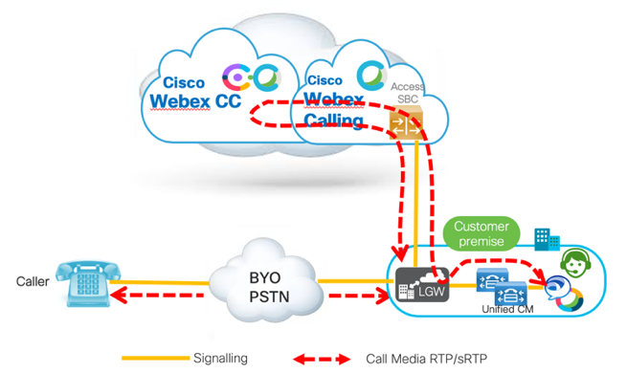

#### Cloud Connected PSTN with Webex Calling (Option 5)

Cloud Connected PSTN (CCP) is a cloud-based option for PSTN access for Webex Calling endpoints (see Figure 11). PSTN access is facilitated by a cloud PSTN provider. If you transition to all cloud services including Webex Calling and Webex Contact Center, then there will not be a requirement for on-premises equipment (except IP phones) as PSTN access will be facilitated by the cloud PSTN provider. Webex Contact Center with Webex Calling will provide ‘on-net’ calling to agent devices, which provides additional savings.

To get the list of all **Cloud Connected PSTN providers** refer to the *Global availability and Cloud Connected PSTN options for Cisco Webex Calling* posting on Cisco Communities available at <https://community.cisco.com/t5/collaboration-voice-and-video/global-availability-and-cloud-connected-pstn-options-for-cisco/ta-p/3916211>.

In addition, **Webex Calling’s country availability** can be found in the *Where is Cisco Webex Available* article available at <https://help.webex.com/en-us/n6fwepj/Where-is-Cisco-Webex-Available#id_98285>.

Figure 11. *Webex Calling and Cloud Connected PSTN (CCP) Signaling and RTP Flow*

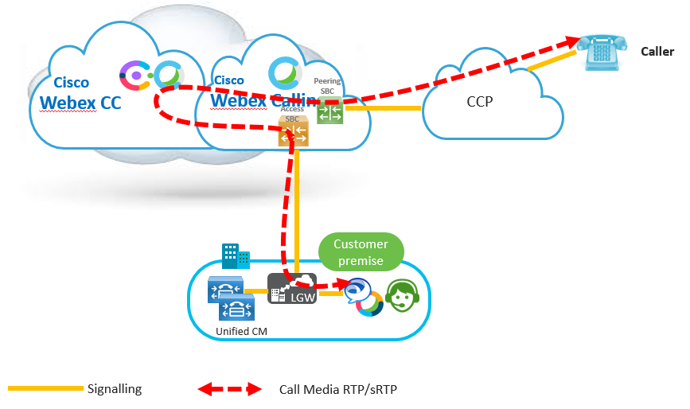

1. Understanding differences between UCCX and Webex Contact Center

#### Terminologies

When you transition to Webex Contact Center, there are few new terminologies that you need to get familiarized with. Table 5 lists some of the most common Cisco Webex Contact Center terminologies, and the corresponding Cisco Contact Center Express (UCCX) terminologies.

Table 5. *Most Common Webex Contact Center and Corresponding UCCX Terminologies*

|  |  |
| --- | --- |
| Terminologies | Comment |
| Call Associated Data (CAD) | Used to store the caller or agent entered data which can be used in routing scripts. The corresponding terminology in UCCX is Call Variables and Expanded Call Context (ECC) Variables. |
| Entry Point | Used to map a Dialed Number Identification Service (DNIS) within Webex Contact Center. Entry point is then associated to a routing strategy for call treatment/queuing. The corresponding terminology in UCCX is Trigger. |
| Routing Strategy | Associates an Entry Point to Flow Control Script and agent team for omni-channel routing. This corresponds to an Application in UCCX. |
| Flow Control | This is the new drag-and-drop UI within Webex Contact Center, which is used to configure your call routing script. This corresponds to UCCX Script Editor. |
| Resource Files | Used as voice prompt manager. This corresponds to prompt Repository in UCCX. |
| Skill Profile | Skill Profile is a group of Skill Definitions which are associated with agents for their individual skill definition. This is similar to Skill Groups or Contact Service Queues within UCCX. |
| Team | A Team carries the same definition in both UCCX and Webex Contact Center. It is a grouping of agents who perform similar activity. The key difference is, in Webex Contact Center a Team is associated with a Routing Strategy and is used for call distribution to agent. Whereas, in UCCX, Team just carries agents and is not used for call distribution. |
| Queue | Used for call queuing/call waiting in Webex Contact Center. This corresponds to Contact Service Queue in UCCX. |

The call routing and call distribution flow within Webex Contact Center are very similar to UCCX. Figure 12 shows the high-level configuration flow between both Webex Contact Center and UCCX for a call to reach the agent.

When a call reaches the Webex Contact Center, the system matches the incoming DNIS to an Entry Point. The Entry Point acts like a trigger (Route Point) in UCCX and associates the call to a Routing Strategy. The Routing Strategy checks for time-of-day routing and verifies for business hours to see if the contact center is open currently. If the call has been delivered during open business hours, it routes the call to Flow Control script associated with Routing Strategy. Flow Control script is similar to a UCCX script editor script, where you define the call treatment and queuing. When the agent becomes available, the call is moved to a queue Routing Strategy which contains the agent teams and call distribution logic to forward the call to an agent phone.

Figure 12. *Configuration flow comparison between Webex Contact Center and UCCX*

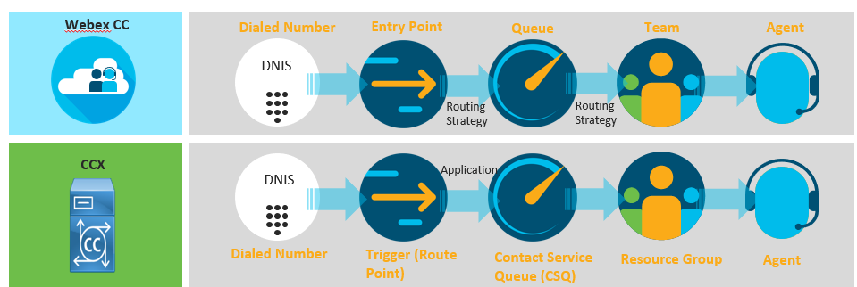

#### Administration

Webex Contact Center administration is done on two portals:

1. Webex Control Hub.

Webex Control Hub serves as a central hub to configure and administer Webex Contact Center. Administrators can utilize Webex Control Hub to configure users, integrate the system to corporate Active Directory (using Directory Connector), add PSTN extensions/DIDs to the system, configure chat templates, integrate with Google Dialogflow for artificial intelligence integrations and manage other collaboration portfolio components such as Webex Calling, Webex Meetings, and so on.

Webex Control Hub is also used to configure connectors in Webex Contact Center. You have options to setup a Salesforce connector, a connector for Webex Experience Management integration, a Google Connector for Text-to-Speech (TTS) service, as well as any custom connectors that you would like to configure for use within your call routing scripts.

1. Webex Contact Center Management Portal.

All other advanced configurations pertaining to Webex Contact Center are carried out on Webex Contact Center Management Portal. Administrators will use the Management Portal for configuring user profiles, multimedia profiles, sites, teams, routing strategy, and so on.

For more information on Webex Contact Center Management Portal refer to the latest *Cisco Webex Contact Center Setup and Administration Guide* available at <https://www.cisco.com/c/en/us/td/docs/voice_ip_comm/cust_contact/contact_center/webexcc/Setup-and-Administration-Guide-WxCC-10/b_mp-release-1.html>.

Administrators will need to get familiarized with the new scripting tool available in Webex Contact Center, called the Flow Control Designer. This will be vital for creating call routing scripts in the system. Flow Control is event-based routing tool where administrators can configure a flow (script) based on an event.

For example, a new call coming into the system is considered an event and administrators can configure a flow for this specific event. Since this is event based, administrators can leverage flow control designer to configure flows based on multiple events like HTTP requests, new call, Kafka messages, and so on.

For more information on Flow Control Designer refer to Webex Contact Center administration guide available at

<add the Webex 2.0 admin guide here which provides in depth information on flow control>

#### User Experience

The Webex Contact Center Agent Desktop has been developed to provide the same look and feel that their on-premises Finesse Desktop provided, thereby providing for a short learning curve. Agents will have the same “page” and “tab” approach that they are used to within their new Webex Contact Center desktop, and administrators can configure their own custom gadgets/widgets and add them to specific team layouts.

The Agent and Supervisor experiences change slightly when you transition from a on-premises UCCX to the cloud-based Webex Contact Center. Agents will need to be trained on phone control with the Webex Contact Center agent desktop, login/logout procedures, status changes, outbound dialing, and so on during this transition.

Refer to Figure 13 and Figure 14 for a comparison of the look and feel of the existing Finesse agent desktop used with UCCX and the new Webex Contact Center agent desktop.

Figure 13. *Existing Finesse Agent Desktop*

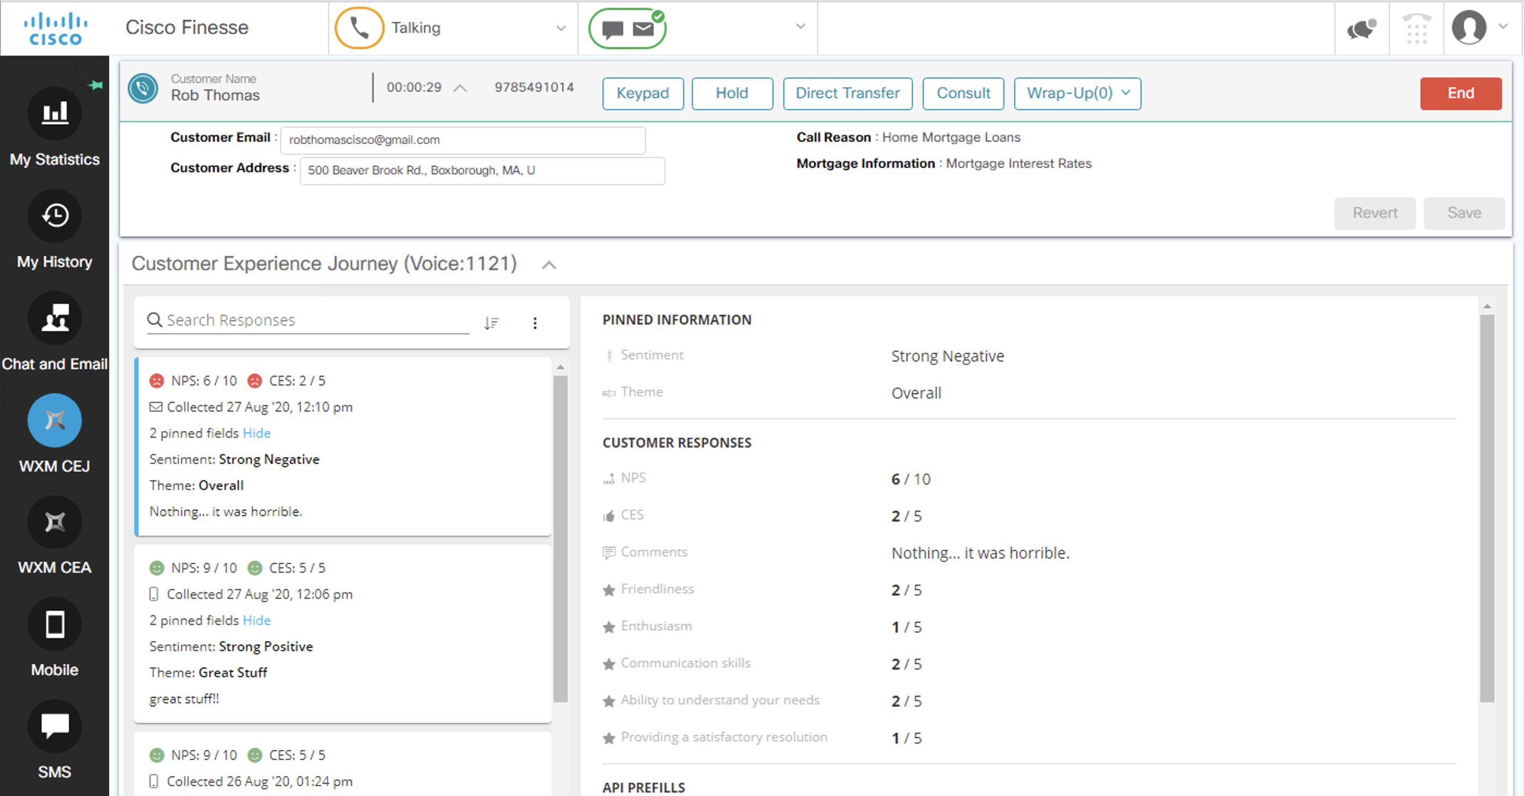

Figure 14. New Webex Contact Center Agent Desktop

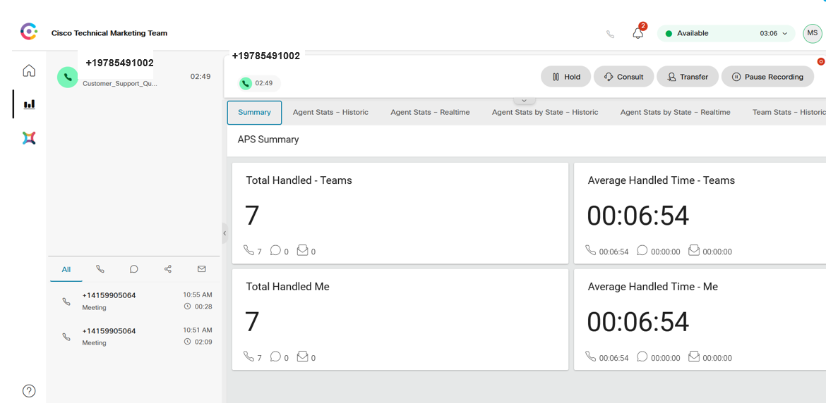

#### Reporting Considerations

Reporting in a contact center plays a key role in understanding critical operational metrics. They provide crucial insights about your contact center and help administrators understand some of the metrics like average handled time, agent login/log out time, percentage of abandoned calls, service level commitment thresholds, and so forth. Administrators and supervisors also rely on historical reporting and workforce optimization analytics, to determine if their teams are staffed adequately to handle the projected contact center traffic, understand skill set gaps within their teams, and to assess and recommend possible training requirements for their agents.

In UCCX, Cisco Unified Intelligence Center (CUIC) provides the interface to interact with the UCCX system and run necessary real time and historical reports. The single sign-on feature in UCCX and CUIC helps supervisors to login to the same CUIC user interface (UI) where they can review just their own teams’ data and run reports. The authentication and authorization mechanism offered by single sign-on with CUIC helps administrators to differentiate the permissions for each user within the contact center system, so they have access to run their specific team reports.

When you transition to Webex Contact Center, your administrators will need to familiarize themselves with the new Webex Analyzer interface which is used for reporting. This will replace the on-premises Cisco Unified Intelligence Center (CUIC) reporting and offers traditional operational metrics as well as advanced business analytics, that go beyond what CUIC offers. The Analyzer mines real-time and historical data from multiple data sources and systems to generate specific business views of the data. Analyzer’s standard visualizations tie traditional operational metrics together with business metrics, providing visibility across both the operational and business performance indicators within a single, consolidated dashboard/view.

For more information on Analyzer, you can refer to the latest *Cisco Webex Contact Center Analyzer User Guide* available at <https://www.cisco.com/c/en/us/td/docs/voice_ip_comm/cust_contact/contact_center/webexcc/Analyzer_1/b_analyzeronlinehelp1_0.html>.

UCCX offers customers and administrators ability to run both CUIC and Analyzer reporting for the UCCX platform, so they can familiarize themselves with Analyzer’s user interface and its advanced capabilities. In this hybrid reporting deployment, administrators can leverage the Cloud Connect service available in UCCX release 12.5 to integrate their on-premises UCCX system to the cloud Webex Analyzer. Once the system is integrated, UCCX sends the abandoned call records to Analyzer and administrators can utilize the default reports and dashboards available to view the abandoned call metrics. This helps administrators to get a feel of Analyzer and understand how it mines data. Additional valuable dashboards will be introduced and made automatically available to you over time as the Analyzer is updated within the cloud.

Figure 15 shows the cloud connect service with UCCX and its connection to Webex cloud.

Figure 15. *Cloud Connect Service in UCCX Providing Connectivity to Webex Cloud*

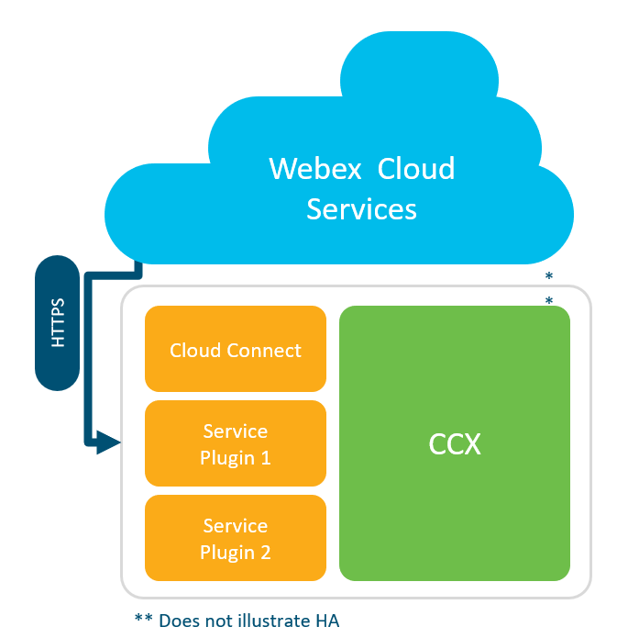

Currently it is not possible to move on-premises UCCX reporting data to cloud Webex Contact Center. Though cloud connect service does offer this capability, currently it is restricted to call abandoned information and does not extend to any other data. Also, the way data is categorized in UCCX and Analyzer differs, therefore, currently there is not a direct 1:1 to mapping between UCCX and Analyzer reports. Table 6 and Table 7 below give an idea of how the data is added into the UCCX and Analyzer database tables.

Table 6 shows the basic call activity and record activity at each stage of the call in UCCX system. The call details are categorized into five main tables in UCCX: Agent Connection Details (ACDR), Agent State Detail (ASDR), Contact Call Detail (CCDR), Contact Queue Detail (CQDR), and Contact Routing Detail (CRDR).

Table 6. *Understanding UCCX Reporting*

|  |  |
| --- | --- |
| Call Activity | Detail Record Activity |
| Call reaches CTI Port | Session allocated begins CCDR in memory |
| Call executes the Setup Resource step | Begins CRDR and CQDR memory |
| System selects agent and rings phone | Begins ACDR in memory, writes ASDR to change agent state |
| Agent Answers | Writes ASDR (talking) |
| Call Disconnects | Writes CRDR, CQDRs, ASDR (work) |
| Agent leaves work state | Writes ACDR, CCDR and ASDR (ready) |

Table 7 shows the basic call activity and record activity at each stage of the call in Webex Contact Center system. The call details are categorized into four main tables: Agent Activity Record (AAR), Agent Session Record (ASR), Customer Activity Record (CAR), and Customer Session Record (CSR).

Table 7. *Understanding Webex Contact Center Reporting*

|  |  |
| --- | --- |
| Call Activity | Detail Record Activity |
| Call reaches Entry Point | Session allocated in CSR |
| Call assigned to a queue | CAR and CSR records |
| System selects agents and rings phone | ASR, AAR and CSR are updated |
| Agent Answers | Writes ASR and AAR |
| Call Disconnects | Writes CAR, ASR and AAR |
| Agent leaves work state | Writes ASR and AAR |

#### 3rd party integrations

On-premises UCCX systems offer customers options to integrate with a wide variety of 3rd party applications for external data dip, customer relationship management (CRM) integration, and so on. Understand your current setup/integration and validate if they are supported with Webex Contact Center. Webex Contact Center offers customers options to integrate with Salesforce, Google for TTS, as well as their own custom integrations. As part of your security audit, consider validating if there are any security concerns with moving 3rd party integrations to the cloud. Some integrations require cloud-to-cloud communications.

## Transition Steps and Considerations

Below is a summary of steps required for transitioning from on-premises UCCX to Webex Contact Center in the cloud. Before proceeding you should back up your collaboration and infrastructure systems (including UCCX), in the event that you must back out or abandon the transition.

**Note:** There is currently no mechanism available for transferring existing UCCX configuration to Webex Contact Center. All of the necessary configuration, needs to be carried out on Webex Contact Center for proper functioning of the solution. All of the necessary steps needed to get a voice call working in this transition are explained below.

Follow these transition steps to move from UCCX to Webex Contact Center:

1. Order Webex Contact Center

In order to begin the transition, a Webex Contact Center organization with proper licensing is required.

For information on ordering Webex Contact Center and licensing, start with the *Cisco Webex Contact Center Data Sheet* available at <https://www.cisco.com/c/en/us/products/collateral/contact-center/webex-contact-center/datasheet-c78-742822.html>.

And for CUBE licenses, please refer to CUBE datasheet at <https://www.cisco.com/c/en/us/products/collateral/unified-communications/unified-border-element/data-sheet-c78-729692.html#Licensing>

1. Implement required network and firewall changes

The first step in transitioning to Webex Contact Center is ensuring that there is connectivity over the internet between the on-premises network and the Webex cloud. Most organizations do not connect directly to the internet, but instead connect through one or more firewalls. For this reason, it is important to understand the traffic flows required between the on-premises network and Webex Contact Center. Network and security administrators must understand these flows in terms of direction, protocols, IP addresses, and port numbers so that corporate firewalls and other network components can be configured to accommodate this traffic.

<Add port reference guide here if there is one for WxCC…>

1. Prepare Webex Control Hub for directory integration and user provisioning

Before enabling directory integration between the corporate directory and the Webex cloud identity store, the following directory integration steps should be taken:

1. Add and verify organization domain(s).
2. Claim organization domain(s).
3. Set up Single Sign-On (SSO).
4. Suppress automated user email invitation.

Each step is explained in detail below.

#### Add and verify organization domain(s)

To add a domain to your Webex organization, use the **Add Domain** option under **Organizational** **Settings > Domain** in Webex Control Hub (<https://admin.webex.com/>). Start by entering the administrator domain and click **Add**. Then find the verification token by selecting **Retrieve verification token** (available by clicking the ellipsis (…) next to the domain name). This verification token must then be added as a DNS TXT record to your DNS host. Once this is done click **Verify** next to the domain. If successfully verified, you will see “Verified” next to your domain. Repeat this process for each domain owned by your organization.

**Note:** You must add and verify the administrator domain first. Failure to do so will result in administrator lockout.

#### Claim Organization domain(s)

As a further security measure, claim your organization domain(s). By claiming your domain(s), you are marking an email domain for use only in your Cisco Webex organization. This prevents users within the claimed domain from existing in any other organization.

To claim a domain for your Webex organization, under **Organizational** **Settings > Domain** in Webex Control Hub (<https://admin.webex.com>), click the ellipsis (…) next to the domain you have added and verified previously and select **Claim verified domain**. After claiming the domain, you will see “Claimed” next to your domain. Repeat this process for each domain owned by your organization.

**Note:** Once a domain is claimed, any administrator outside of your organization that attempts to add a user with this domain will receive an error message.

For more information on adding, verifying, and claiming domains, refer to the *Add, Verify and Claim Domains* article available at <https://help.webex.com/en-us/nxz79m5/Add-Verify-and-Claim-Domains>.

#### Setup SSO

While optional, the use of single sign-on (SSO) is recommended to provide the best end-user experience. The benefit of SSO is that a user can use a single common set of credentials for authenticating any Webex service as well as other collaboration and on-premises applications. With SSO, a user must provide credentials a single time per session in order to be authorized for any services they are subscribed to.

To enable SSO for the Webex organization, from Webex Control Hub navigate to **Organizational Settings** and scroll down to **Authentication**, click the **Modify** and then, select the **Integrate a 3rd-party identity provider (Advanced)**. Next, click the **Download Metadata File** button to download the file for importing to your Identity Provider (IdP).

Return to Webex Control Hub and on the Import IdP Metadata screen, drag and drop the IdP metadata file or navigate to the file using the file browser. Next, under *Signing of Metadata (Advanced),* select **Require certificate signed by a certificate authority in Metadata (more secure),** (unless IdP certificate is not signed by the CA, in which case you can select the less secure **Allow self-signed certificate in Metadata** option).

Finally, test the SSO setup by clicking the **Test SSO Connection** button. When prompted enter the valid SSO credentials to confirm SSO is working properly. Assuming the test is successful, select **This test was successful. Enable Single Sign-On** and click **Next** to complete the SSO configuration.

For more information on tested IdPs and enabling SSO for your Webex org, refer to the *Single Sign-On Integration in Cisco Webex Control Hub* article available at <https://help.webex.com/en-us/lfu88u/Single-Sign-On-Integration-in-Cisco-Webex-Control-Hub>.

#### Suppress automated user email invitation

You should prevent automated email invitations that would be sent to users in your organization in order to activate users without interaction. These email invitations are not necessary and can cause confusion. These automated emails provide an initial password (not required with SSO), request user validate their activation (not required with verified domain), and request that users provide additional user account details (not required with Directory Connector LDAP integration).

To prevent these automated invitations, from Webex Control Hub navigate to **Organization Settings**, scroll to **Enroll** and toggle the **Suppress Admin Invite Emails** setting to on and click **Save**.

**Note:** This option is only available when Single Sign-On is enabled.

1. Enable Directory Connector integration

The preferred method for importing and synchronizing users between the on-premises corporate directory and the identity store in Webex Contact Center, is to use hybrid directory service with Directory Connector. In addition to initially importing users into the cloud identity, it is imperative to perform regular synchronization of user information between the corporate directory and the cloud identity store so that the latest user information is available in Webex Contact Center.

Directory Connector, running on a windows domain server, retrieves the user information from the corporate Active Directory and synchronizes to the cloud identity store using REST based APIs. This synchronization is performed at regular intervals (manually or setup automatically) to ensure the cloud identity store is up to date with on-premises corporate directory. Directory Connector software can be downloaded from the Cisco Webex Control Hub and installed on a local machine.

For information on how to deploy and configure Directory Connector refer the *Deployment Guide for Cisco Directory Connector* available at <https://www.cisco.com/c/en/us/td/docs/voice_ip_comm/cloudCollaboration/spark/hybridservices/directoryconnector/cmgt_b_directory-connector-guide-admins.html>.

1. Provision users for Webex Contact Center

After installing the Directory Connector and running the sync, all synchronized users will now be available in Webex Control Hub. If you chose not to install Directory Connector for LDAP directory integration with the cloud, you must add users manually in Webex Control Hub under **Management > Users**. Once users are available in Webex Control Hub use bulk update (recommended) to enable appropriate users for Webex Contact Center, and to also assign them Webex Contact Center Premium or Webex Contact Center Standard services.

The CSV template for this update can be downloaded from Webex Control Hub by clicking **Manage Users** and selecting **CSV Add or Modify Users** option. To avoid errors, you can export all users, filter out the users to modify, and then update the settings only for a selected set of users.

In the CSV file, update the column **Webex Contact Center Premium** to **TRUE** if the agent is a premium agent. If the agent is a standard agent, update column **Webex Contact Center Standard** to **TRUE.**  For users designated as Supervisor or Administrator, enable the services manually from Webex Control Hub. To manually enable services for a user, click on the user and select the **Webex Teams** check box under Messaging. Under Customer Care Contact Center select the **Contact Center** check box**.**  Under Assign License Type select **Supervisor** and then, **Save***.*

For more details on adding users to Webex Contact Center refer to the *Ways to Add Users for Cisco Webex Contact Center* article available at <https://help.webex.com/en-us/52ulis/Ways-to-Add-Users-for-Cisco-Webex-Contact-Center>.

Once the users are added in Webex Control Hub, they need to be synchronized with Webex Contact Center Management Portal. This step needs to be performed manually. To perform the manual sync, navigate to **Services** > **Contact Center** and select **Settings** tab. Click on **Synchronize Users** under the Synchronize Users section.

Completing the above steps will **not** enable contact center privileges for the configured agents and supervisors. Our next step will be to enable **Contact Center** privileges for these users in Webex Contact Center Management Portal. Before we enable this for users in the portal, we need to configure other contact center related settings such as Agent Teams, Skill Profile, Agent Profile and the Multimedia Profile to assign to the agent. These are described in step 7.

1. Configure dialed number (DN) for Webex Contact Center call routing

You need to configure a dialed number in Webex Control Hub for contact center call routing. You will map this DN to an entry point in Webex Contact Center Management Portal for call treatment and queuing (this is discussed in step 8 Configure call routing section). To configure the DN, navigate to **Services > Contact Center > Settings** in Control Hub and scroll to **Telephony Settings.** Under **Inbound Dial Numbers** box, add your incoming dialed number DN and **hit tab**. Click on **Add** button after entering the DN. This will move the DN to ‘Available Numbers’ section as shown in Figure 16.

Figure 16. *DN Moved to Available Numbers after Adding in Webex Control Hub*

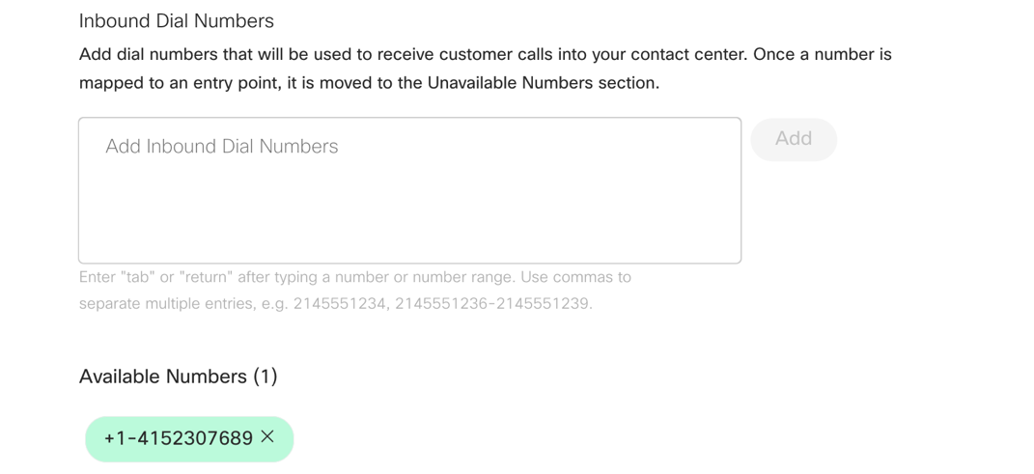

This DN needs to be routable from on-premises CUBE to the cloud. This is discussed in detail in step 8. Configure call routing below.

1. Configure agent settings (Teams, Agent Profile, Skill Profile and Multimedia Profile)

Our next step is to configure agent settings in the Management Portal. These settings are required and needed when we enable the **Contact Center Enabled** privilege in Management Portal.

You can reach the Webex Contact Center Management Portal by cross launching from Webex Control Hub. To do this, navigate to **Services** > **Contact Center** scroll to **Advanced Configuration** section and click on **Go to Webex Contact Center Management Portal.** You can also browse directly to the portal by typing <https://portal.cjp.cisco.com/portal> in your browser.

Once you have navigated to the Webex Contact Center Management Portal, the first step is to configure a **Site**. A site is a logical grouping of users and configurations pertaining to a specific site or location within Webex Contact Center. In a typical Contact Center deployment, agents are spread across different geographical locations. You can leverage site configuration to logically group them and assign specific configuration to a group. To configure, click on **hamburger menu icon at the left of the portal** () > **Provisioning** **>** **Site > New Site.** Add a new site. Each site is associated with a multimedia profile. But since we have not configured a multimedia profile yet, select the system default profile. This can be revisited once we configure the multimedia profile.

It is recommended to configure individual sites for each geographic location so as an admin, you can logically separate the users and assign same set of configurations to users belonging to a site.

Next, configure **Agent Profile(s)**. An agent profile consists of general configuration information pertaining to an agent and can be assigned to users within Webex Contact Center. It is a group of permissions and Agent Desktop behaviors that you assign to specific agents. Each agent profile specifies the following permissions and settings:

* Queue Transfers
* Agent Consult and Transfer
* Wrap up and Idle Codes
* Agent Auto Available
* Dial Number Capabilities
* Access to Agent Personal Statistics
* Agent Thresholds
* Out-dial capabilities

To configure an agent profile, navigate to the **hamburger menu icon at the left of the portal** () > **Provisioning** **>** **Agent Profile > New Agent Profile.** Enable necessary settings in the profile and **Save** the configuration.

The next step in our configuration flow is to enable **Multimedia Profile**. This setting specifies the number of chats, emails and voice/telephone contacts that the agent can handle simultaneously. You can assign a multimedia profile to a site, a team, or an agent.

By default, Webex Contact Center assigns the *Default_Telephony_Profile* to every site. The order of precedence is: **Agent – Teams – Site**. If there is no multimedia profile assigned at an agent level, the system will look for team configuration, and if the profile is not assigned at team level, then the system will check for the profile configuration at the site level.

To configure a multimedia profile in the portal, navigate to the **hamburger menu icon at the left of the portal** () > **Provisioning** **>** **Multimedia Profile > New Multimedia Profile.** Under **Media Details, select Blended, Blended Real-Time, or Exclusive** depending on your business requirement.

* *Blended Media* type allows agents to handle multiple contacts of different channel types simultaneously. You can define an upper limit for each channel type.
* *Blended Real-Time* allows agents to handle a contact of one real-time channel at a time – either chat or voice. Along with this they can handle non-realtime contacts which include email and social channels.
* *Exclusive Media* type allows agents to focus on one customer contact at a time. You can select the channel types for which the agents receive contacts in Exclusive Media type.Assign the number of simultaneous email, voice, and chat contacts that an agent can handle under **Media Details** section, and then **Save** the configuration.

Next, add a **Skill Definition** and a **Skill Profile**. Skill-based routing is optional in Webex Contact Center, but it is recommended. This enables you to assign skill requirements, such as product expertise, language fluency and so on, to the incoming requests (call, email and chat) so they can be distributed to agents with the matching skill(s).

Navigate to the **hamburger menu icon at the left of the portal** () > **Provisioning** **>** **Skills > Skill Definition > New Skill Definition** to configure agent skills. You can configure the skills based on Proficiency, Enum, Boolean or Text. Once you configure a skill definition, this can be assigned to a skill profile, which in turn can be assigned an agent or a team. Click **Save** once you are done with the skill definition configuration.

Browse to the **hamburger menu icon at the left of the portal** () > **Provisioning** **>** **Skills > Skill Profile > New Skill Profile** to configure the profile and assign skill definitions to the profile. You can assign multiple skill definitions to a skill profile.

For example, you can configure a skill profile with English language proficiency as the highest and a foreign language at a lower proficiency. When this profile is assigned to an agent, English speaking customer calls will be routed to this agent. If a skill profile is assigned to a team, all agents logged in to that team are associated with that skill profile, unless the agent is assigned a specific skill profile. Click **Save** once the configuration is complete.

Our final step before enabling **Contact Center Enabled** privileges to users is to configure **Teams**. Team is a group of users who support a specific group of functions. For example, a team supporting billing, a team supporting platinum customers, and so on. A team consists of agents and is associated with a specific site.

**Note:** Once a team is associated with a specific site, it cannot be changed. The only option to move a team to another site, is to delete the team and recreate it.

To configure a team, browse to the **hamburger menu icon at the left of the portal** () > **Provisioning** **>** **Team > New Team.** Associate the new team to its specific site and associate necessary configurations like the skill profile, multimedia profile, and desktop layout at the team level. When agents are added to a team, they inherit these configurations if they are not explicitly mentioned at the user level.

Now, browse to the **hamburger menu icon at the left of the portal** () > **Provisioning** **>** **Users.** Select the user(s) you want to enable the **Contact Center Enabled** privilege for. Once this is enabled, scroll down to **Agent Settings** to assign skill profile, multimedia profile, agent profile, team and site information. In phase 1 (hybrid deployment), enable this privilege only to users who will be logging in to Webex Contact Center system to accept contact center calls.

**Note:** Once an agent is associated with a specific site, it cannot be changed. Please take care when associating a site to an agent.

The next step in this transition is to configure call routing scripts and route calls from UCCX to Webex Contact Center. This is discussed in the next step.

For more detailed information on configuration steps refer to the *Cisco Webex Contact Center Setup and Administration Guide* available at; <https://www.cisco.com/c/en/us/td/docs/voice_ip_comm/cust_contact/contact_center/webexcc/Setup-and-Administration-Guide-WxCC-10/b_mp-release-1.html>*.*

<Management Portal guide is subject to change once 2.0 is released>

1. Configure call routing

During the transition, to allow for coexistence of both Webex Contact Center and UCCX (temporary hybrid model), it is imperative that you decide which PSTN option you want to go with.

The most common scenario will be for customers to leverage their existing on-premises PSTN connectivity to route calls between UCCX and Webex Contact Center. As noted previously, this document only discusses the details for the Bring Your Own PSTN (BYO PSTN) option.

With BYO PSTN, you can use the existing DID extensions which continues to initially route all calls to UCCX, and then have UCCX decide which calls to transfer to Webex Contact Center based on certain criteria. Alternatively, you have an option to configure a separate dedicated Direct Inward Dial (DID) extension which routes specific calls to Webex Contact Center. In either case, the agent phones continue to be registered to your on-premises Unified CM for call processing during the hybrid phase.

#### UCCX performing call distribution

##### Overview

This will be the most common flow customers will adopt during their hybrid deployment. In this call flow, the if-and-when decision to distribute certain calls to the cloud Webex Contact Center is made within the UCCX system.

It is recommended to have a group of agents designated as an “overflow” team, or a completely different team outside of the UCCX configured teams and agents, to handle these transferred calls from your on-premises UCCX system to the cloud Webex Contact Center. Combining agents who are part of same Contact Service Queue (CSQ)/team between UCCX and Webex Contact Center is not recommended, as this can create reporting discrepancies and administrators would have to refer to reports from both the on-premises and cloud contact center platforms to get complete call and agent statistics.

You can configure your UCCX script with specific criterion for overflow decision making. Decision-making criteria include the number of agents logged in to queue, queue overflow, most skilled agent, and so on.

Continue leveraging your existing service provider supplied toll-free and toll numbers to route calls to UCCX. When UCCX needs to send the call to the cloud, you must configure a E.164 internal extension to forward them to Webex Contact Center over your data network (Access Network). This is an advantage in terms of cost saving, as you don’t have to purchase a new DID from service provider to route calls to Webex Contact Center.

Figure 17 shows the call flow when we are using a hybrid model with both Webex Contact Center and Contact Center Express.

Figure 17. *Call Flow with On-Premises UCCX and Cloud-based Webex Contact Center*

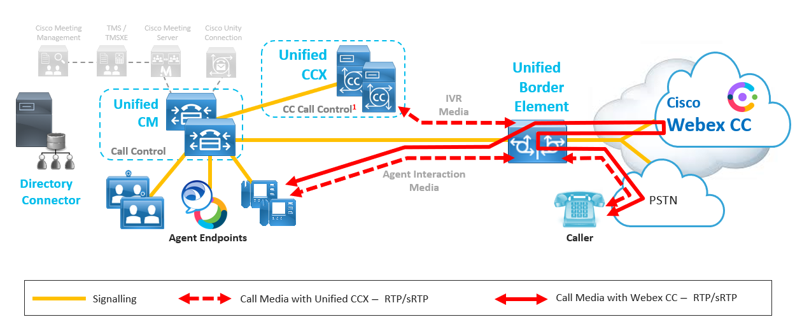

The call flow is as follows:

* The initial call hits the CUBE (ingress) at the on-premises corporate network, which then forwards the call to Unified CM.
* Unified CM matches the incoming dialed number to a CTI route point and forwards the call to UCCX.
* UCCX matches the incoming call to a trigger assigned to an application/ script and provides call treatment based on the script associated. Before associating the call to a UCCX script, the UCCX system transfers the call from a CTI route point to a CTI port. For more information on UCCX call flows refer to the *Solution Design Guide for Cisco Unified Contact Center Express* available at <https://www.cisco.com/c/en/us/td/docs/voice_ip_comm/cust_contact/contact_center/crs/express_12_5/design/guide/uccx_b_solution-design-guide-125.html>.
* UCCX continues to provide call treatment (IVR, queuing) for this call. If the call matches configured criteria requiring the call to be transferred to Webex Contact Center in the cloud, UCCX will then send a “call redirect” request to the Unified CM.
* The Unified CM matches the request to a route pattern (RP) and forwards the call to the CUBE.
* The dial-peer configured in CUBE matches this incoming request and extends the call to Webex Contact Center, where further call treatment and queuing are provided.
* When an agent becomes available, Webex Contact Center reserves the agent and forwards the call to on-premises CUBE.
* CUBE then extends the call to Unified CM and in turn to the agent phone.

Assuming that the configuration to route calls from the PSTN to UCCX is already in place from existing deployment, here are the configuration steps you need to follow when adopting this flow.

##### Configurations needed on your on-premises servers

1. Install Microsoft SQL Server.
2. Configure a route pattern with an E.164 dialed number (DN) in Unified CM.
3. Configure the UCCX script with a call redirect and DB write step.
4. Configure the CUBE with dial-peers to route calls to Webex Contact Center and agent extensions.
5. Install the DB Connector tool in your on-premises environment for external database lookup.

Each of these steps are discussed in detail below:

1. Install Microsoft SQL Server.

The first step for hybrid deployment call routing is to install and configure Microsoft SQL Server. Install SQL server 2016 (tested) on an on-premises Windows machine along with SQL Management Studio. Once the installation is complete, open the SQL Management Studio and login with ‘sa’ credentials. Under Object Explorer, right click on Databases folder and select **New Database**. Provide a meaningful name to the database (for example, CCX2WxCC) and change the initial DB size to 100 MB and **click OK**. This creates the CCX2WxCC database instance that UCCX will connect to for writing call variable data of a call. Webex Contact Center and DB Connector connect to this SQL server to fetch call variable details for a transferred/ redirected call.

1. Configure a route pattern with an E.164 dialed number (DN) in Unified CM.

Configure a 10-digit dialed number (DN) as your route pattern which serves as a DID to reach Webex Contact Center from on-premises. You need to share this DID extension with the Cisco Solution Assurance team. The Solution Assurance team will perform the backend CUBE configuration within the vPOP, to route the calls to your Webex Contact Center tenant.

Associate a route group or a SIP trunk to this route pattern which forwards calls to the CUBE. Make sure the calling search space of UCCX CTI route point in Unified CM has access to the partition associated with this route pattern. For complete steps on how to configure route pattern and/or route groups, refer to the call routing information available in the *System Configuration Guide for Unified CM* located at <https://www.cisco.com/c/en/us/td/docs/voice_ip_comm/cucm/admin/12_5_1/systemConfig/cucm_b_system-configuration-guide-1251/cucm_b_system-configuration-guide-1251_chapter_010100.html>.

1. Configure the UCCX script with a call redirect and DB write step.

You will need to configure your UCCX script with the necessary condition to forward calls to Webex Contact Center. The specific condition to match depends on the business need and can vary from customer to customer. Some of the most common criteria include: if the wait time for a call in-queue is higher than an acceptable limit, if the number of agents logged in and available for calls is lower than a set limit, if the queue is full and you want to overflow, and so on.

Configure your UCCX script to match the appropriate criteria that solves your business needs. Therefore, if an incoming call matches this criteria or condition, configure a call redirect step to transfer the call out of UCCX and over to Webex Contact Center.

You will also need to configure a database (DB) write step in the UCCX script to write call variable information to an external SQL DB. This external SQL DB is used by the on-premises DB Connector and cloud Webex Contact Center to fetch call variable data when the call is transferred to the cloud. This helps the cloud contact center to avoid requesting same information which the caller has already provided when interacting with your on-premises UCCX server.

Figure 18 shows a sample UCCX script with a specific condition to fulfill for a call to be moved to Cisco Webex Contact Center. In this example, the UCCX system is checking for “number of logged in agents” in a Contact Service Queue (CSQ). If the number of agents logged in is 0, then the call is transferred to the specified Webex Contact Center pilot/DID extension. But before the call is transferred to Webex Contact Center, UCCX script runs a DB write step which connects to the SQL server and writes the meaningful call variable data obtained from the caller. UCCX script also has a DB read step prior to DB write to verify that the connectivity between UCCX and the SQL server is up and active.

Figure 18. *Sample UCCX Script with Call Redirect Step*

You can obtain the sample UCCX script with this call redirect and DB write step from GitHub repository available at:

<https://github.com/fkicenko/dbconnector/UCCX2WxCC.aef>.

1. Configure the CUBE with dial-peers to route these redirected calls to Webex Contact Center.

When Unified CM receives the “call redirect” request for the Webex Contact Center pilot number, it matches the route pattern (RP) configured in step ii of these configuration steps and extends the call to the CUBE.

You need to configure the necessary dial-peers to match this pilot extension and forward the call to Webex Contact Center/vPOP CUBE. The vPOP CUBE supports only SIP protocol for this interaction and the communication between the two should be encrypted.

When an agent becomes available, Webex Contact Center sends the call to the on-premises CUBE to connect to the agent’s directory number. Configure dial-peers in CUBE to reach agent extension if they are not already configured.

Figure 19 shows an example of the dial-peer configuration needed in on-premises CUBE to route the call to Webex Contact Center.

Figure 19. *Example of CUBE Dial-peer to Forward Call to Pilot Extension*

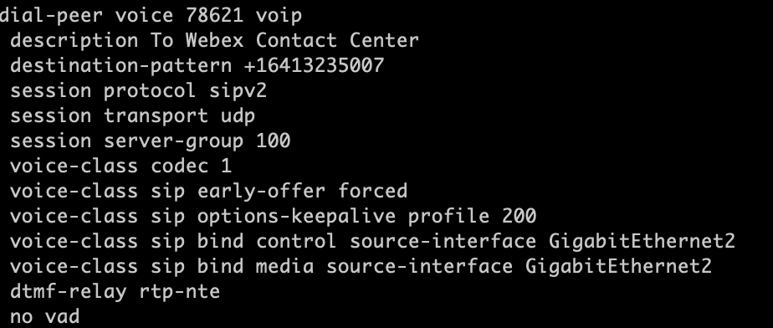

**Note:** Figure 19 only show the outgoing dial-peer configuration. The incoming dial-peer is not shown.

1. Install the DB Connector tool in your on-premises environment for external database lookup.

The tool is available at <https://github.com/fkicenko/dbconnector>.

##### Configurations needed on Webex Contact Center

1. Configure an entry point.
2. Map an entry point to a dialed number (DN).
3. Create queues.
4. Configure custom connector for external database dip to fetch call specific data (call variables).
5. Upload necessary prompts or WAV files to Webex Contact Center.
6. Configure flow control script.
7. Configure routing strategy for entry point and assign flow control script.
8. Configure routing strategy for queue and assign teams to distribute the calls to.

These configuration steps are discussed in detail below:

1. Configure an entry point.

First, for Webex Contact Center call routing configure an entry point. An entry point is the initial landing place for the customer contacts on Webex Contact Center system. For the voice contacts, typically one or more toll-free or dial numbers can be associated with an entry point. In a UCCX environment, this relates to a trigger.

To configure an entry point, navigate to the hamburger **menu at the left of the portal** (  ) > **Provisioning** **>** **Entry Point/Queues > Entry Point > New Entry Point.** Select the channel type (Chat, Email or Telephony) under **General Settings** and Service Level Threshold value under **Advanced Settings**. Save the configuration once complete.

1. Map an entry point to a dialed number (DN).

Next, map the entry point to a dialed number. Before performing this mapping, verify a dialed number is added in Webex Control Hub (discussed in step 6 of this section).

To map a DN to an entry point, navigate to the hamburger **menu at the left of the portal** (  ) > **Provisioning** **>** **Entry Point Mappings > New Mapping.** From **Available Numbers** dropdown, select the DN configured in Webex Control Hub. If a DN is already associated with a different entry point, then those DNs will not show up in the drop down. Select save once the configuration is complete.

1. Create queues.

A queue is where active calls are kept while they await handling by an agent. Contacts are moved from the entry point into a queue and are then distributed to agents. To configure queues, navigate to the hamburger **menu at the left of the portal** (  ) > **Provisioning** **>** **Entry Points/Queues > Queue > New Queue.** Provide the channel type in **General Settings** and in **Advanced Settings** configure other optional elements like Permit Call Monitoring, Permit Call Recording, Pause/Resume, and so on. Also configure Service Level Threshold and Maximum Time in Queue under **Advanced Settings**. Maximum Value in Queue defines the time a call can wait in queue for agent assignment before it is perhaps moved to an overflow number. Save the configuration once complete.

1. Configure custom connector for external database dip to fetch call specific data (call variables).

Configure a custom connector in Webex Control Hub to fetch call related data from on-premises server(s). When the calls are redirected from on-premises UCCX to Webex Contact Center, we need to preserve call specific data (call variables) for example, user account number, user ID information, membership details, and so on. This keeps callers from having to repeat themselves when a call is transferred from on-premises UCCX to cloud Webex Contact Center. We use the external DB lookup using custom connector to fetch these call variable data from on-premises UCCX system to present them on the Webex Contact Center agent desktop or to provide unique personal experience after the call redirect.

Before configuring the DB connector, make sure you have installed the on-premises DB connector software as discussed under the Configurations needed on your on-premises serverssection of this document.

To configure a custom DB connector, login to Webex Control Hub and navigate to **Services > Contact Center > Connectors**. Select **‘Set up’** under **Custom Connectors** option. Provide a name for the connector, Resource Domain, username, and password. The Resource domain is the HTTPS URL to reach the web server hosting DB connector on-premises. Click Done once the configuration is complete.

Figure 20 shows a sample custom connector configuration.

Figure 20. *Sample Custom Connector configuration*

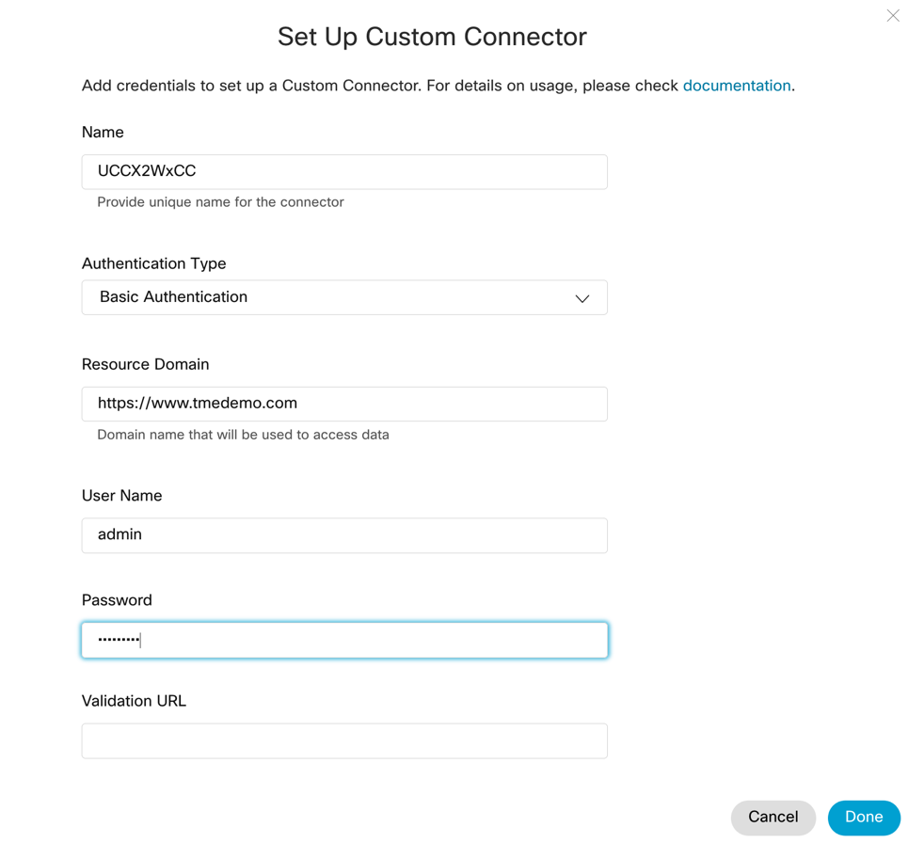

1. Upload necessary prompts or WAV files to Webex Contact Center.

Upload necessary IVR prompts or WAV files to Webex Contact Center from UCCX. The wav files need to be CCIT U-law, 8-bit sample and 8kHz sample rate for Webex Contact Center. To upload the WAV file, navigate to the **hamburger menu at the left of the portal** (  ) > **Routing Strategy**. This will open a new window. In the new window, navigate to **Resources > Audio Files.** Upload the custom WAV files to the system.

1. Configure flow control script

Flow Control is the drag-and-drop scripting tool used to configure call routing scripts within Webex Contact Center. With Flow Control, you can configure your omni-channel customer contact flows to match your business’ needs. The Flow Control tool is the cloud equivalent of the CCX Script Editor in the on-premises UCCX system.

We currently don’t have a tool to migrate existing UCCX scripts from on-premises to cloud Webex Contact Center, so be sure to configure all necessary call routing scripts in cloud contact center before the agent transition.

Figure 21 and Figure 22 shows the Flow Control UI with a sample call routing script. The Main Flow tab (see Figure 21) in the UI is used to provide call treatment. Administrators can use this tab to define what IVR prompts to play, which queue to route the call to, and so on.

Figure 21. *Flow Control User Interface: Main Flow Tab*

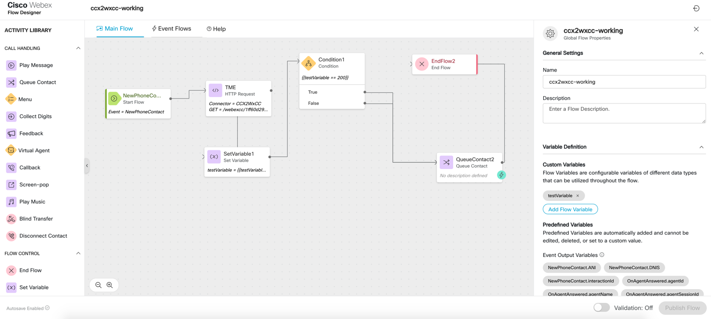

The Event Flow tab (see Figure 22) is used to configure specific responses for an event. For example, administrators can configure a screen pop response for an agent-answered-call event.

Figure 22. *Flow Control User Interface: Event Flow Tab*

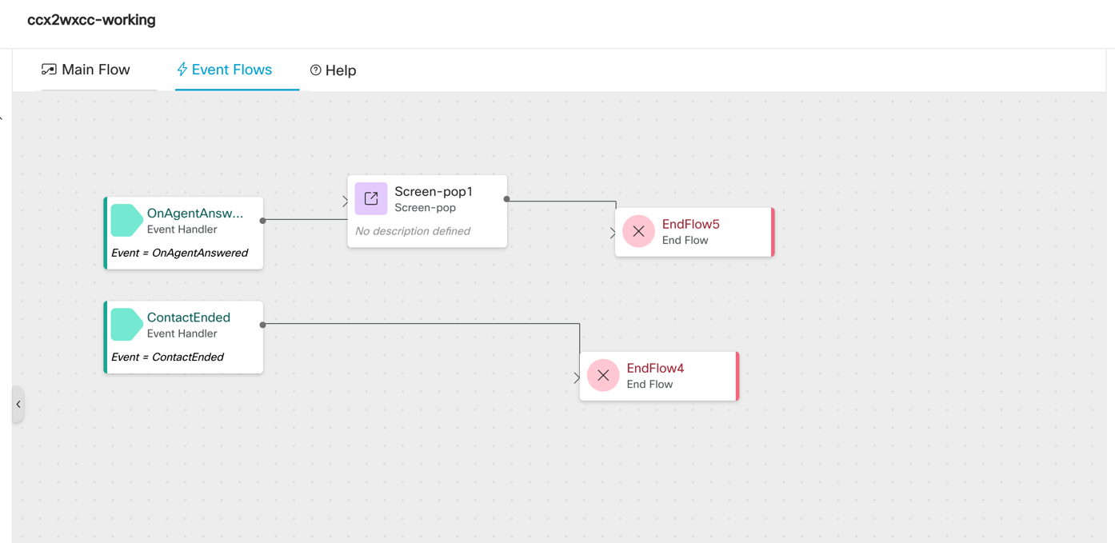

During the hybrid phase, when the calls are redirected by UCCX, we leverage the custom connector configured to fetch call variables from the on-premises server, so callers don’t have to repeat data which was already shared during their interaction with UCCX.

To fetch data from the on-premises DB connector, leverage the **‘HTTP Request’** node available in Flow Control. Configure HTTP Request node with GET Restful API method to DB connector by passing the endpoint ID (for example 9280c139-xxxx-xxxx-xxxx-33982f1d8069).

You can leverage the data received from the on-premises DB connector to make business decisions and route calls appropriately within the Flow Control script. You can also assign the parsed data from HTTP Request to a custom variable defined in flow control and enable the custom variable as a CAD variable to display on agent desktop. To configure a custom variable, click on **Global Flow Control** properties by clicking on Flow Designer UI and selecting **Add Flow Variable** under **Variable Definition > Custom Variable**. Configure **Variable Type** as String/Integer depending on data parsed and enable **Mark as CAD Variable** and enter **Desktop Label**.

To send the HTTP GET request, highlight the **HTTP Request** node and under **HTTP Request Settings** enable **Use Authenticated Endpoint** and select the custom DB connector from the connector drop down. Under Request Path provide the web server URL running DB connector along with endpoint ID (for example https://<FQDN_of_webserver>/rest/webexcc/9280c139-xxxx-xxxx-xxxx-33982f1d8069)

To parse the JSON response, highlight **HTTP Request** node and scroll to **Parse Settings**. Set **Content Type** to JSON, select the Output Variable from drop down and finally set the JSON path of the variable under JSONPath Expression.

Figure 23 shows a sample Flow Control script configuration with **HTTP request** node.

Figure 23. *HTTP Request node with connector and Request Path URL*

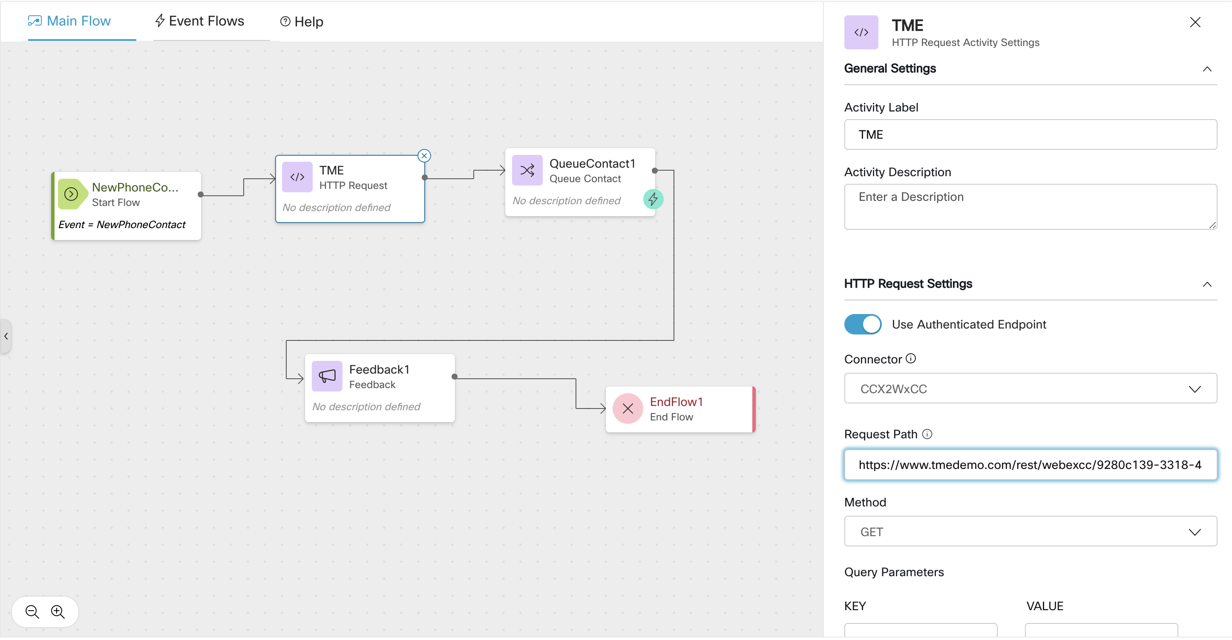

Alternately, if you want to just display call variable data in agent desktop, you can also configure a screen-pop on your agent desktop to fetch and display a web page which has these call variables loaded. This does require a web server to be built (on-premises or cloud) which can fetch data using a DB connector. To configure this method, leverage **‘Screen-pop’** node available in Flow Control. Add this node in ‘Event Flows’ tab after ‘OnAgentAnswered’ Event as shown in Figure 22 above and configure the screen-pop URL pointing to the web server.

Figure 24 shows agent desktop with call variables fetched from on-premises UCCX using DB connector. Data is displayed as a screen pop.

Figure 24. *Agent Desktop interface with call variables fetched from on-premises and configured as screen-pop*

1. Configure routing strategy for entry point and assign flow control script

After configuring the flow control script, we need to associate this script to a routing strategy. When a contact arrives, the routing engine checks for a global routing strategy associated with the entry point for the current time. If a routing strategy exists, the system invokes the flow associated with this routing strategy to provide appropriate call treatment.

Associating flow control script to a routing strategy enables the system to move an incoming call to a routing script for IVR treatment. To perform this task, navigate to the **hamburger menu at the left of the portal** (  ) > **Routing Strategy**. This will open a new window. In the new window, select your entry point from **Select Entry Point/Queue** drop-down menu. Select **New Strategy** and provide a name to your routing strategy. Under the Time Settings section, configure the start date and end date followed by start time and end time when this routing strategy can be invoked. This is similar to time of the day routing in UCCX. If a call comes in outside of the start and end time or start and end date specified in the routing strategy, then the routing engine will not associate the call to the routing strategy and therefore the call will not be forwarded to the flow control script. Save after completing the configuration.

Figure 25 shows a routing strategy configuration which has a start time of 8 AM and an end time of 5 PM during the weekdays as well as a flow control script associated with it.

Figure 25. *Entry Point Routing Strategy with Flow Control Associated*

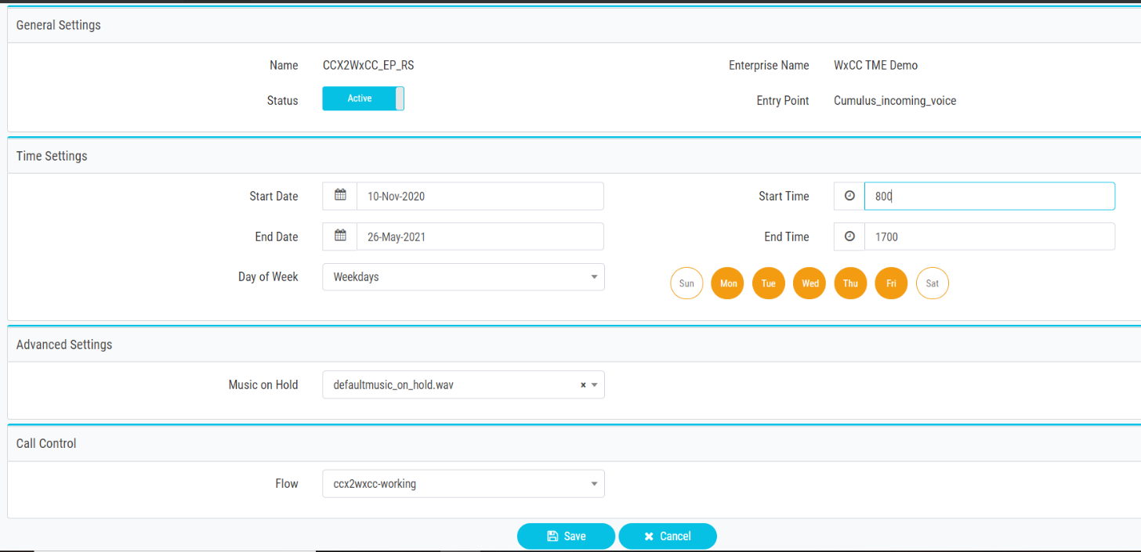

1. Configure routing strategy for the queue and assign teams to distribute the calls to.

One of our final steps is to configure a routing strategy for the queue. This is required to distribute call to appropriate agent team and agent for call handling.

To configure a queue routing strategy, navigate to the **hamburger menu at the left of the portal** (  ) > **Routing Strategy**. This will open a new window. In the new window, select your queue from **Select Entry Point/Queue** drop-down menu. Select **New Strategy.** Select the appropriate routing type. You can choose either Longest Available Agent or Skills Based. The common method will be skill-based routing. Provide start date, end date, start time, and end time when the call should hit this routing strategy. Under the Call Distribution section, select Add Group and associate the team(s) you want the call to be distributed to when it hits this queue routing strategy. Save the configuration.

#### CUBE performing call distribution

##### Overview

The second common method to distribute a call to Webex Contact Center from the on-premises system using Bring Your Own PSTN (BYO PSTN), is to have a dedicated service provider DID terminating on an on-premises CUBE, which is configured to forward all calls reaching this pilot number to the cloud Webex Contact Center.

This requires purchasing a dedicated DID from your current service provider. This flow is adopted in scenarios where you want to get familiar with the look and feel of Webex Contact Center and train your agents and supervisors, before performing a full transition to a purely cloud-based contact center deployment.

You will continue to use UCCX and Webex Contact Center in this hybrid phase. UCCX continues to handle calls to any other pre-existing contact center DIDs.

You have two options when it comes to who distributes the call to Webex Contact Center:

* Configure your CUBE to extend all calls reaching the new Webex Contact Center pilot number to the cloud; or
* Configure CUBE to forward all calls to Unified CM and configure Unified CM to distribute calls to the cloud Webex Contact Center.

Whether you opt for CUBE-based or Unified CM-based call distribution is determined based on you reporting requirements. If your organization requires you to have Unified CM call detail records (CDRs) for calls made to the Webex Contact Center pilot number, you can choose to forward all calls from CUBE to Unified CM (although call records for this DID can also be obtained from the Webex Contact Center Analyzer tool).

The recommended method is to have CUBE distribute the call to Webex Contact Center.

Figure 26 shows the signaling and RTP flow in a hybrid deployment with CUBE performing the call distribution.

Figure 26. *CUBE Distributed Call Flow with UCCX and Webex Contact Center*



The call flow is as follows:

* The initial call hits the CUBE (ingress) at the on-premises corporate network.
* A dial-peer configuration within the CUBE extends the call to Webex Contact Center.
* Webex Contact Center provides further call treatment for the incoming call.
* When the agent becomes available, Webex Contact Center reserves the agent and forwards the call back to the CUBE.
* The CUBE extends the call to Unified CM and then to the agent device.
* The call’s RTP flow always hairpins through the Webex Contact Center, even though the PSTN, CUBE and agent devices are all located on the customer premises. This flow is as designed, to provide additional functionality offerings such as call recording, call monitoring, and so on.

Assuming you are leveraging the existing configuration between the CUBE and Unified CM for corporate call routing and UCCX call routing, here are the configuration steps you need to follow when adopting this flow.

##### Configurations needed on your on-premises servers

Configure dial-peers in CUBE for the Webex Contact Center pilot number and agent extensions.

Since the call distribution is done by the CUBE, the only on-premises configuration needed in this flow is adding appropriate dial-peers within the CUBE.

Configure your CUBE to extend calls to the cloud Webex Contact Center for the dedicated DID number(s) obtained from your service provider. The vPOP CUBE supports only SIP protocol for this interaction and the communication between the two should be encrypted (TLS).

When an agent becomes available, Webex Contact Center reserves the agent and sends the call back to the on-premises CUBE. To handle this request, configure necessary dial-peers in CUBE to route calls to agent extensions.

Figure 27 shows an example of CUBE dial-peer configuration for this call flow.

Figure 27. *CUBE Dial-peers for Extending Specific Calls to Webex Contact Center*

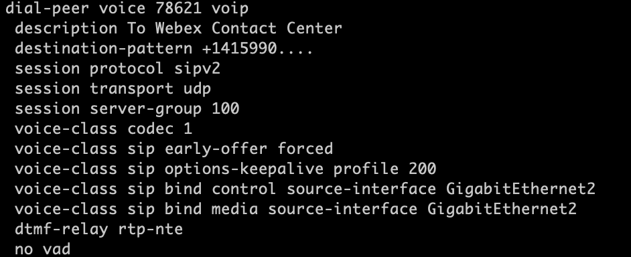 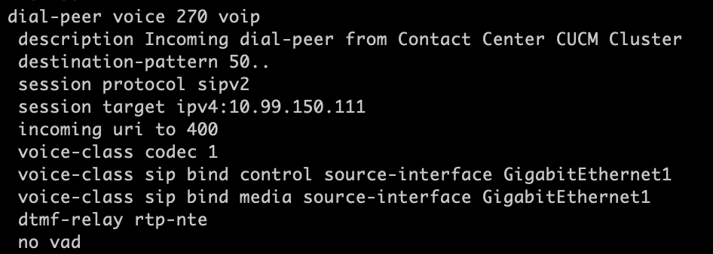

**Note:** Figure 27 shows only the outgoing dial-peer configuration to Webex Contact Center and Unified CM. Incoming dial-peer(s) are not shown.

##### Configurations needed on Webex Contact Center

1. Configure an entry point.
2. Map an entry point to a dialed number (DN).
3. Create queues.
4. Upload necessary prompts or WAV files to Webex Contact Center.
5. Configure flow control script.
6. Configure routing strategy for entry point and assign flow control script.
7. Configure routing strategy for queue and assign teams to distribute the calls to.

These steps are discussed in detail below

1. Configure an entry point.

The first step in Webex Contact Center call routing is to configure an entry point. An entry point is the initial landing place for the customer contacts into a Webex Contact Center system. For the voice contacts, typically one or more toll-free or dial numbers can be associated with an entry point. In a UCCX environment, this relates to a trigger.

To configure an entry point, navigate to the **hamburger menu at the left of the portal** (  ) > **Provisioning** **>** **Entry Point/Queues > Entry Point > New Entry Point.** Select the channel type (Chat, Email or Telephony) under **General Settings** and **Service Level Threshold** value under **Advanced Settings**. Save the configuration once complete.

1. Map an entry point to a dialed number (DN).

The next step is to map the entry point to a dialed number. Before performing this mapping, verify that a dialed number has been added within the Webex Control Hub (discussed in step 6 of this section).

To map a DN to an entry point, navigate to the **hamburger menu at the left of the portal** (  ) > **Provisioning** **>** **Entry Point Mappings > New Mapping.** From **Available Numbers** dropdown, select the DN configured in Webex Control Hub. If a DN is already associated with an entry point, then those DNs will not show up in the drop down. Select **Save** once the configuration is complete.

1. Create queues.

A queue is where active calls are kept while they await handling by an agent. Contacts are moved from the entry point into a queue and are distributed to agents. To configure queues, navigate to the **hamburger menu at the left of the portal** (  ) > **Provisioning** **>** **Entry Points/Queues > Queue > New Queue.** Provide the **Channel Type** in **General Settings** and in **Advanced Settings** configure other optional elements like Permit Call Monitoring, Permit Call Recording, Pause/Resume, and so on. Also configure Service Level Threshold and Maximum Time in Queue under **Advanced Settings**. Maximum Value in Queue defines the time a call can wait in queue for agent assignment before it is moved to a configured overflow number. Save the configuration once complete.

1. Upload necessary prompts or WAV files to Webex Contact Center.

Upload necessary IVR prompts or WAV files to Webex Contact Center from UCCX. The WAV files need to be CCIT U-law, 8-bit sample and 8kHz sample rate to work properly within the Webex Contact Center. To upload the WAV file, navigate to the **hamburger menu at the left of the portal** (  ) > **Routing Strategy**. This will open a new window. In the new window, navigate to **Resources > Audio Files.** Upload the custom **wav** files to the system.

These files will not be available when configuring flow control script for call routing.

1. Configure flow control script.

Flow Control is a new drag-and-drop scripting tool which addresses the limitations of control script. With flow control you can configure your flow, based on events thereby allowing administrators to leverage the tool for omni-channel routing configuration. This relates to CCX Script Editor in on-premises UCCX. We currently don’t have a tool to migrate existing UCCX scripts from on-premises to cloud-based Webex Contact Center. Be sure to configure all necessary call routing scripts in cloud contact center before the agent transition.

For more information on flow control refer to <provide document on flow control here>

1. Configure routing strategy for entry point and assign flow control script.

After configuring the flow control script, we need to associate this script to a routing strategy. When a call arrives, the routing engine checks for a global routing strategy associated with the entry point for the current time. If a routing strategy exists, the system invokes the flow associated with this routing strategy to provide appropriate call treatment.

Associating Flow Control script to a routing strategy enables the system to move an incoming call to a routing script for IVR treatment. To perform this task, navigate to the **hamburger menu at the left of the portal** (  ) > **Routing Strategy**. This will open a new window. In the new window, select your entry point from **Select Entry Point/Queue** drop-down menu. Select **New Strategy** and provide a name to your routing strategy. Under Time Settings section, configure the start date and end date followed by start time and end time when this routing strategy can be invoked. This is like time of the day routing in UCCX. If a call comes in outside of the start and end time or start and end date specified in the routing strategy, then the routing engine will not associate the call to the routing strategy and thereby the call will not be forwarded to the flow control script. Save after completing the configuration.

Figure 28 shows a routing strategy configuration which has a start time of 8 AM and an end time of 5 PM during the weekdays as well as a flow control script associated with it.

Figure 28. *Entry Point Routing Strategy with Flow Control Associated*



1. Configure routing strategy for queue and assign teams to distribute the calls to.

One of our final steps is to configure a routing strategy for the queue. This is required to distribute a call to the appropriate agent team and agent for call handling.

To configure a queue routing strategy, navigate to the **hamburger menu at the left of the portal** (  ) > **Routing Strategy**. This will open a new window. In the new window, select your queue from **Select Entry Point/Queue** drop-down menu. Select **New Strategy.** Select the routing type appropriately. You can choose either Longest Available Agent or Skills Based. The common method will be skill-based routing. Provide start date, end date, start time, and end time when the call should hit this routing strategy. Under the Call Distribution section, select Add Group and associate the team(s) you want the call to be distributed to when it hits this queue routing strategy. Save the configuration.

1. Transition agents to Webex Contact Center

The final step in this transition is to move agents from on-premises UCCX to Webex Contact Center. In a hybrid deployment (phase 1), transition only the users who are going to login and accept calls on Webex Contact Center. As part of this process, train your agents and supervisors on the new agent desktop so they are familiar with day-to-day contact center operations. Webex Contact Center desktop tries to provide the same look and feel of an on-premises Finesse agent desktop with widgets. It carries the same functionality that Finesse offered such as toaster notifications, resize/drag/drop widgets, custom widgets, agent state timer, and so on. But there are some features that requires training, for example call control in new agent desktop, the new dashboards and agent statistics, keyboard shortcuts, placing outbound calls, and so on.

Delete any reference of these users (agents and supervisors) from UCCX configuration to avoid any confusion. Deleting these users from UCCX will not remove any historical records. The historical records pertaining to transitioned agents and supervisors will remain in the UCCX database. After the transition, the reporting data will be accessible for contacts made into the Webex Contact Center and can be viewed and analyzed using the native analyzer tool.

1. Transition fully to Webex Contact Center

The final phase (phase 2) of this transition is to move fully to cloud-based Webex Contact Center solution and decommission your existing on-premises UCCX platform. How long a customer remains in the hybrid environment before transitioning to completely cloud-based contact center can vary. Before you transition to cloud, make sure your organization has familiarized themselves with Webex Contact Center platform. Some of the key considerations during this transition are:

* Understand all the features Webex Contact Center can offer and determine if it matches your organization’s requirement.
* Ensure that the agents and supervisors have familiarized themselves with and are fully comfortable with the new Webex Contact Center desktop.
* Ensure that the administrators are comfortable with configuring, managing, and maintaining the new platform.
* Make sure that you are familiar with reporting and dashboard operations.
* If you are using BYO PSTN, ensure that you have evaluated the CUBE licensing requirements.
* Understand how to integrate 3rd party applications during your hybrid phase and be sure you have fully tested their integrations with Webex Contact Center.
* Ensure that you have tested chat and email functionality during the hybrid phase.

To move fully to a pure cloud-based contact center deployment, configure all your contact center DIDs to route to Webex Contact Center. This is done by configuring necessary dial-peers in the CUBE to extend calls to the vPOP.

Replicate the teams, queues, entry point, routing strategy and flow control configurations discussed earlier for the rest of your contact center. Delete any references in Unified CM or the CUBE which might route calls to Unified UCCX.

If you are using SocialMiner with UCCX for chat and email, configure your Webex Contact Center appropriately. Since we cannot run chat and email as a hybrid contact center deployment, this is not discussed in this document.

Move your 3rd party integrations to cloud Webex Contact Center and finally, decommission your on-premises UCCX to complete the transition and move entirely to the Webex Contact Center cloud environment.

Figure 28 shows the signaling and RTP flow for a Webex-only contact center deployment with on-premises Unified CM. This flow is same as when CUBE performs call distribution as discussed earlier in the *Configure call routing* section (step 8) of this section.

**Note:** On-premises unified CM will continue to provide call processing capabilities until call control is transitioned to Webex Calling.

Figure 29. *Call Flow with Webex Contact Center and On-premises Unified CM*

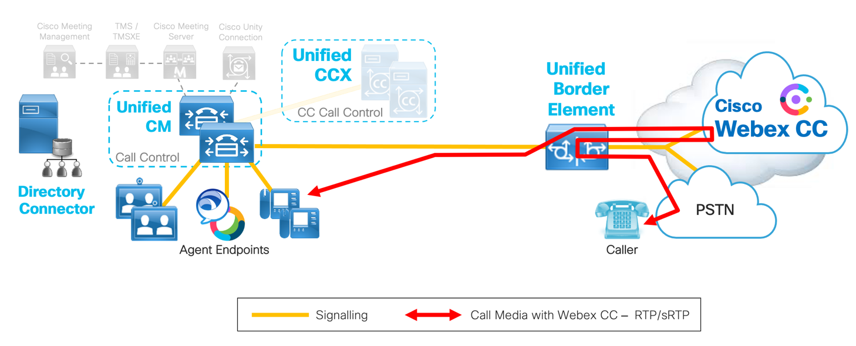

## Post Transition Steps and Considerations

After the transition is completed, there are additional optional steps you may wish to consider:

1. Replace BYO PSTN with Cisco Bundled PSTN service.

To meet the needs of our broad customer base, Cisco is now making available the option to purchase Cisco PSTN for contact center agents alongside our cloud contact center solutions.

Cisco PSTN voice services for Webex Contact Center eliminate the complexities of managing telecom infrastructure and can enable customers to deploy a robust cloud contact center with calling functionality in less than 5 business days.

Cisco PSTN provides toll-free, toll/DID and toll/outbound voice services with the simplicity of a consolidated billing for contact center solutions and PSTN.

**Note:** Other voice traffic including e911 calls are not supported on this Cisco Bundled PSTN service.

This PSTN offer provides two telephony options that can be purchased as add-ons and includes:

1. **Base telephony bundle**

Provides local number access into Webex Contact Center or Webex Contact

Center Enterprise + PSTN termination of the call to the agent (available in the contiguous US + Canada).

1. **Toll-free access bundle**

Enables toll-free calling for Webex Contact Center or Webex Contact Center Enterprise (available in the contiguous US).

Benefits of these PSTN options include:

* Quick deployment (typically 5 business days or less from order placement).
* Predictable monthly cost with “all you can call” usage, priced per agent.
* Flexible agent volume scaling to respond to fluctuating demands.
* Full support for remote agents. Cisco PSTN can be used with any telephony solution the agent has today including home phone line, cell phone, and office DID.
* Single vendor and combined bill managed by Cisco.
* Rapid ramp up for existing contact center overflow or public response teams.

For details, please consult the *Cisco Webex Contact Center Ordering Guide* available at <https://www.cisco.com/c/en/us/products/collateral/customer-collaboration/guide-c07-741218.html>.

1. Replace your Unified CM with Webex Calling.

Webex Calling is a proven cloud calling solution that delivers enterprise-grade calling, enabling you to replace your PBX network with a globally trusted cloud solution. It easily extends to a complete collaboration experience that includes market-leading calling, meetings, teams, contact center, and integrated devices for all situations.

Webex Calling integration will allow you able to terminate both the inbound contact center DNIS number(s) as well as the agent endpoints directly onto the Cisco Webex Calling platform. As shown in Figure 30, by combining the Webex Calling deployment with Cloud Connected PSTN provided by a Cisco cloud partner, the need for an on-premises or partner-hosted CUBE and Unified CM is eliminated while still gaining the same business benefits for the calling solution that you get when transitioning your contact center to the cloud.

Figure 30. *Cloud Connected PSTN with Webex Calling*

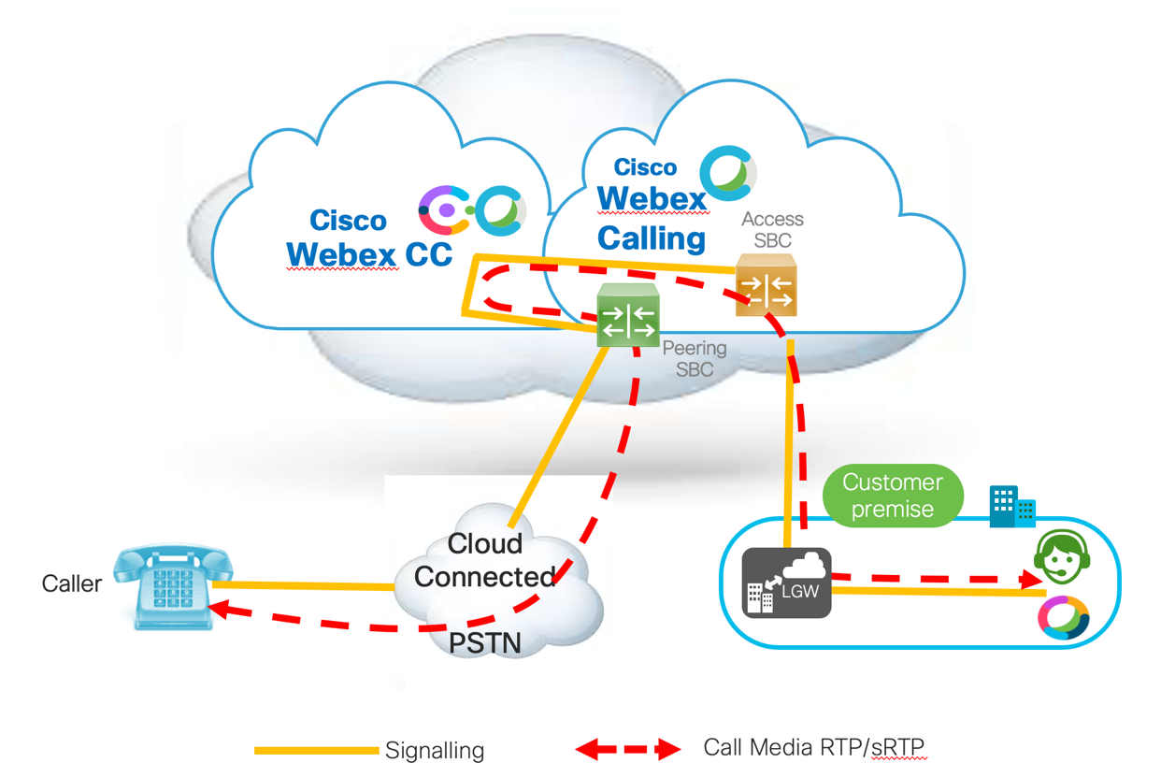

For information on Cisco phone model support for Webex Calling refer to the *Supported Devices for Webex Calling* article available at <https://help.webex.com/en-us/qkwt4j/Supported-Devices-for-Webex-Calling>.

1. Consider omni-channel capabilities for Webex Contact Center.

The Webex Contact Center enables optional omni-channel capabilities including:

* Email

The subject line of emails is scanned for business-specific keywords to decide the skill group or queue to which they need to be routed. Once the emails are placed inside a queue, the work distribution engine assigns them to available agents based on the queuing algorithm selected in the system. Agents can then respond to emails with a standard email response template and have full visibility into past interactions with that customer.

* Chat

Chat uses the Webex messaging infrastructure to communicate between the customer and agent.

Customers connect with an agent via a chat bubble on the organization’s website. Customers can select a reason for interaction from a drop-down menu. The selected reason is used to route the customer interaction to the appropriate queue. Chat interactions are then assigned to an agent based on the configured routing strategy, for instance “longest available agent”.

* Social Interactions

An organization may integrate their social business account(s) (starting with Facebook Messenger) for customer care to respond to customer needs initiated via social media.

**Note:** Email, chat and social interactions capabilities are included with Premium Agent seats only.

1. Enable ASR / TTS integrations.

Speech-enabled IVR is a sophisticated customer engagement solution powered by text-to-speech (TTS), automatic speech recognition (ASR), and the automation of complex end-user tasks. This solution is priced as an a la carte Webex Contact Center feature.

The feature set includes:

* + - * Touch-tone (DTMF) caller inputs.
      * Multilingual Automated Speech Recognition (ASR).
      * Open-ended speech responses.
      * Multilingual Text-To-Speech (TTS).
      * Third-party integrations.
      * Screen-pop data collected in IVR passed to agents.
      * Real-time and historical reports.
      * Browser-based, drag-and-drop call flow builder.

1. Enable 3rd party integrations with custom connectors.

Webex Contact Center is based on an open platform surrounded by several APIs and interfaces. This allows it to easily integrate with other in-house and off-the-shelf products and applications to leverage existing systems and investments.

This open platform also allows Webex Contact Center to integrate with other applications in the marketplace to create unique end-to-end solutions for customers. Webex Contact Center APIs allow 3rd parties to develop software to leverage and extend Webex Contact Center capabilities.

1. Integrate with CRMs using CRM connectors.

Webex Contact Center has pre-built connectors for integration with several industry-leading customer relationship management (CRM) systems, including Salesforce, Zendesk, and MS Dynamics.

Additionally, the Cisco Professional Services team can help deliver integration with other CRM applications as a custom paid professional services engagement.

As part of the integration, data about the customer and the context of the call is delivered to the agent in an automatic screen pop.

Webex Contact Center also logs the interaction within the CRM application to capture the inbound call. The integration enables click-to-dial from within the CRM applications, where the agent can click on a phone number to dial out to the customer. The out-dialed call is automatically logged against the record whose number has been dialed out.

The CRM connectors provide CTI integration between the Webex Contact Center automatic call distributor (ACD) and the customer’s CRM tool. The toolset allows for:

* Agent state control
* Call control
* Click to dial
* Screen pop on Automatic Number ID (ANI) or call variables
* Receiving inbound and placing outbound (click-to-dial) calls from the CRM
* Automatic customer record screen pop in the CRM
* Automatic call activity logging in CRM

1. Leverage contact center artificial intelligence (CCAI).

By implementing Cisco Artificial Intelligence, bots converse naturally with customers, resolving basic issues directly, and assisting human agents on tougher calls. Bots are able to provide real-time, step-by-step guidance as well as continuous interactivity improvements by analyzing conversation transcripts to identify gaps in understanding or requested information. Combining the best of Google Cloud AI with the power of Cisco's contact center platform, contact center AI can improve customer experience and increase operational efficiency at the same time.

1. Utilize Webex Experience Management.

Webex Experience Management is a next-generation, AI-powered cloud customer experience management (CEM) solution that improves customer experiences by giving companies greater insight across the entire customer journey, by mapping their experiences across all touchpoints in the organization, consolidating the data that was once siloed, and using predictive analytics to make informed decisions on how to proactively improve those experiences so that they create positive business outcomes.

Webex Experience Management enables:

* **Customer Journey** **Management** – Listen to your customers across 17 different channels (for example, email, chat, web) along the entire journey, expose and assess areas of improvement to drive loyalty, and leverage the Cisco Contact Center to close the loop.
* **Feedback** – Create and customize various “listening posts” for sentiment and feedback (for example, post-call IVR/email and web intercept surveys to collect customer data).
* **Deep Analytics** – Derive a relationship between operational, transactional, and experience drivers (for example, Net Promoters Score (NPS), Customer Satisfaction (CSAT), and revenue), and use predictive analytics to model Key Performance Indicator (KPI) and financial impact of strategic decisions.

1. Take advantage of Workforce Optimization for workforce and quality management.

The Workforce Optimization application suite includes workforce and quality management capabilities.

Workforce Management solutions offering contact center supervisors, agents, and staffing analysts the ability to dynamically manage agent schedules, forecast and plan staffing based on trends, and ensure adherence to schedules. Key features include:

* Dynamic scheduling - allows agents, supervisors, and staffing analysts to collaborate in creating a schedule that meets everyone’s needs.
* Dynamic intra-day scheduling - enables last-minute scheduling changes.
* Automated agent approval - for exceptions, time off, schedule offer/trade, and mentoring. Provides set workflows to automate approval, denial, waitlisting, and manual handling.
* Agent-initiated peer mentoring – when an agent submits a request and the peer accepts, there is an automated supervisor approval, and both agents’ schedules are updated.
* Gamification of agent KPIs - agents earn badges for quality scores and adherence.
* Strategic planning and forecasting - allow users to forecast staffing needs based on trends.
* Vacation and holiday planning.

Quality management helps customers measure agent efficiency and performance using tailored evaluation forms. Key features include:

* Multichannel quality evaluation - evaluate call, email, and chat interactions.
* Targeted evaluations - find interactions of interest with pinpoint precision using a combination of transaction data, customer data, speech energy, and other business-related metadata.
* Library of customized evaluation forms - percentage or points-based.
* Pinpoint evaluation commenting - add comments to a call and search for comments by questions, section, form, or duration.
* Gamification of agent KPIs - agents earn badges for quality scores and adherence.
* Evaluation calibration - supervisors, managers, and agents can comment on an evaluation for a collaborative approach to quality.
* Automated contact queue - contacts are routed to a contact queue according to workflow configuration.
* Post-call survey data integration with call data makes playback easily accessible during evaluations.
* Export calls - use for training or within e-learning platforms.

1. Enable outbound campaigns option.

The outbound campaigns option improves agent productivity and the overall business performance of a contact center by letting agents spend more time talking to customers and less time trying to reach them.

The outbound campaigns add-on feature provides:

* Outbound campaign management, including campaign chaining.
* Contact list management.
* Advanced contact strategies across multiple contact numbers.
* Automation with preview and progressive dialing.
* Compliance tools.

# References

### <Product / Solution #1>

* <Product / Solution Documentation Reference #1>

https://url

* <Product / Solution Documentation Reference #2>

<https://url>

### <Product / Solution #2>

* <Product / Solution Documentation Reference #3>

https://url

### <Product / Solution #3>

* <Product / Solution Documentation Reference #4>

https://url

* <Product / Solution Documentation Reference #5>

<https://url>

### Collaboration Transitions

* Collaboration Transitions Program Page

<https://www.cisco.com/go/ct>

* Transition Map for Transitioning from Unified CCX to Webex Contact Center

<https://www.cisco.com/c/dam/en/us/td/docs/solutions/PA/mcp/TDM_CONTACT_CENTER_UnifiedCCX_to_WebexCC.pdf>

